# What is Blockchain Technology? A Step-by-Step Guide For Beginners

## Is blockchain technology the new internet?

The blockchain is an undeniably ingenious invention – the brainchild of a person or group of people known by the pseudonym,  [Satoshi Nakamoto](https://en.wikipedia.org/wiki/Satoshi_Nakamoto). But since then, it has evolved into something greater, and the main question every single person is asking is: What is Blockchain?

By allowing digital information to be distributed but not copied, blockchain technology created the backbone of a new type of internet. Originally devised for the[digital currency](http://blockgeeks.com/guides/what-is-cryptocurrency-everything-you-need-to-know-ultimate-guide/), [Bitcoin](http://blockgeeks.com/guides/how-to-buy-bitcoin/),  ([Buy Bitcoin](http://coinsquare.io/register?r=BLOCKGEEKS)) the tech community is now finding other potential uses for the technology.

Bitcoin has been called “digital gold,” and for a good reason. To date, the total value of the currency is close to $9 billion US. And blockchains can make other types of digital value. Like the internet (or your car), you don’t need to know how the blockchain works to use it. However, having a basic knowledge of this new technology shows why it’s considered revolutionary. So, we hope you enjoy this, what is Blockchain guide.

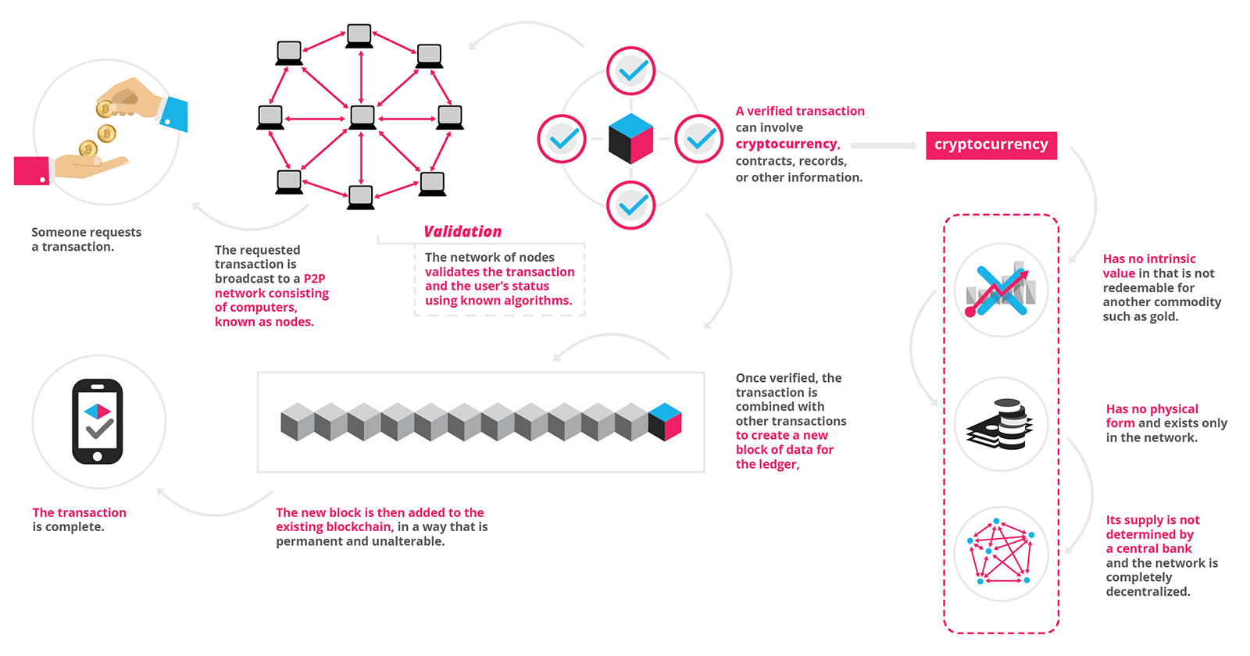

## What is Blockchain Technology?



“The blockchain is an incorruptible digital ledger of economic transactions that can be programmed to record not just financial transactions but virtually everything of value.”  
Don & Alex Tapscott, authors Blockchain Revolution (2016)

## A distributed database

Picture a spreadsheet that is duplicated thousands of times across a network of computers. Then imagine that this network is designed to regularly update this spreadsheet and you have a basic understanding of the blockchain.

## Start Your Free Trial Today

[**Free Trial**](https://courses.blockgeeks.com/enrollment/?utm_source=Guides&utm_medium=Widget&utm_campaign=FromGuides)

Information held on a blockchain exists as a shared — and continually reconciled — database. This is a way of using the network that has obvious benefits. The blockchain database isn’t stored in any single location, meaning the records it keeps are truly public and easily verifiable. No centralized version of this information exists for a hacker to corrupt. Hosted by millions of computers simultaneously, its data is accessible to anyone on the internet.

To go in deeper with the Google spreadsheet analogy, I would like you to read this piece from a blockchain specialist.

## Blockchain as Google Docs



“The traditional way of sharing documents with collaboration is to send a Microsoft Word document to another recipient, and ask them to make revisions to it. The problem with that scenario is that you need to wait until receiving a return copy before you can see or make other changes **because you are locked out of editing it until the other person is done with it. That’s how databases work today. Two owners can’t be messing with the same record at once.**That’s how banks maintain money balances and transfers; they briefly lock access (or decrease the balance) while they make a transfer, then update the other side, then re-open access (or update again).With Google Docs (or Google Sheets), both parties have access to the same document at the same time, and the single version of that document is always visible to both of them. It is like a shared ledger, but it is a shared document. The distributed part comes into play when sharing involves a number of people.

Imagine the number of legal documents that should be used that way. Instead of passing them to each other, losing track of versions, and not being in sync with the other version, why can’t \*all\* business documents become shared instead of transferred back and forth? So many types of legal contracts would be ideal for that kind of workflow.You don’t need a blockchain to share documents, but the shared documents analogy is a powerful one.”

[*William Mougayar, Venture advisor, 4x entrepreneur, marketer, strategist and blockchain specialist*](http://startupmanagement.org/2016/09/06/explaining-the-blockchain-via-a-google-docs-analogy/)

## Blockchain Durability and robustness

Blockchain technology is like the internet in that it has a built-in robustness. By storing blocks of information that are identical across its network, the blockchain cannot:

1. Be controlled by any single entity.
2. Has no single point of failure.

Bitcoin was invented in 2008. Since that time, the Bitcoin blockchain has operated without significant disruption. (To date, any of problems associated with Bitcoin have been due to hacking or mismanagement. In other words, these problems come from bad intention and human error, not flaws in the underlying concepts.)

The internet itself has proven to be durable for almost 30 years. It’s a track record that bodes well for blockchain technology as it continues to be developed.



**“As revolutionary as it sounds, Blockchain truly is a mechanism to bring everyone to the highest degree of accountability. No more missed transactions, human or machine errors, or even an exchange that was not done with the consent of the parties involved. Above anything else, the most critical area where Blockchain helps is to guarantee the validity of a transaction by recording it not only on a main register but a connected distributed system of registers, all of which are connected through a secure validation mechanism.”**

– [Ian Khan**,**TEDx Speaker](http://www.iankhan.com/)| Author | Technology Futurist

## Transparent and incorruptible

The blockchain network lives in a state of consensus, one that automatically checks in with itself every ten minutes.  A kind of self-auditing ecosystem of a digital value, the network reconciles every transaction that happens in ten-minute intervals. Each group of these transactions is referred to as a “block”. Two important properties result from this:

1. **Transparency**data is embedded within the network as a whole, by definition it is public.
2. **It cannot be corrupted**altering any unit of information on the blockchain would mean using a huge amount of computing power to override the entire network.

In theory, this could be possible. In practice, it’s unlikely to happen. Taking control of the system to capture Bitcoins, for instance, would also have the effect of destroying their value.



“Blockchain solves the problem of manipulation. When I speak about it in the West, people say they trust Google, Facebook, or their banks. But the rest of the world doesn’t trust organizations and corporations that much — I mean Africa, India, the Eastern Europe, or Russia. It’s not about the places where people are really rich. Blockchain’s opportunities are the highest in the countries that haven’t reached that level yet.”  
[*Vitalik Buterin, inventor of Ethereum*](http://forklog.net/vitalik-buterin-about-ethereum-smart-contracts-and-himself/)

## A network of nodes

#### A network of so-called computing “nodes” make up the blockchain.

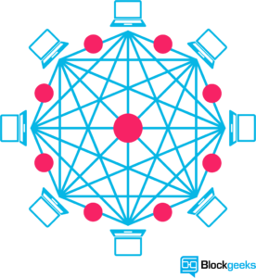

#### Node

(computer connected to the blockchain network using a client that performs the task of validating and relaying transactions) gets a copy of the blockchain, which gets downloaded automatically upon joining the blockchain network.

Together they create a powerful second-level network, a wholly different vision for how the internet can function.

Every node is an “administrator” of the blockchain, and joins the network voluntarily (in this sense, the network is decentralized). However, each one has an incentive for participating in the network: the chance of winning Bitcoins.

Nodes are said to be “mining” Bitcoin, but the term is something of a misnomer. In fact, each one is competing to win Bitcoins by solving computational puzzles. Bitcoin was the raison d’etre of the blockchain as it was originally conceived. It’s now recognized to be only the first of many potential applications of the technology.

There are an estimated 700 Bitcoin-like[cryptocurrencies](http://blockgeeks.com/guides/what-is-cryptocurrency-everything-you-need-to-know-ultimate-guide/) (exchangeable value tokens) already available. As well, a range of other potential adaptations of the original blockchain concept are currently active, or in development.



“Bitcoin has the same character a fax machine had. A single fax machine is a doorstop. The world where everyone has a fax machine is an immensely valuable thing.”  
[*Larry Summers, Former US Secretary of the Treasury*](http://www.coindesk.com/larry-summers-us-treasury-blockchain-can-succeed-without-bitcoin/)

## The idea of decentralization

By design, the blockchain is a decentralized technology.

Anything that happens on it is a function of the network as a whole. Some important implications stem from this. By creating a new way to verify transactions aspects of traditional commerce could become unnecessary. Stock market trades become almost simultaneous on the blockchain, for instance — or it could make types of record keeping, like a land registry, fully public. And decentralization is already a reality.

A global network of computers uses blockchain technology to jointly manage the database that records Bitcoin transactions. That is, Bitcoin is managed by its network, and not any one central authority. Decentralization means the network operates on a user-to-user (or peer-to-peer) basis. The forms of mass collaboration this makes possible are just beginning to be investigated.



“I think decentralized networks will be the next huge wave in technology.”  
[*Melanie Swan, author Blockchain: Blueprint for a New Economy (2015)*](http://fortune.com/2015/03/06/bitcoin-book-boom/)

## Who will use the blockchain?

As web infrastructure, you don’t need to know about the blockchain for it to be useful in your life.

Currently, finance offers the strongest use cases for the technology. International remittances, for instance. The World Bank estimates that over $430 billion US in money transfers were sent in 2015. And at the moment there is a [high demand for blockchain developers](http://courses.blockgeeks.com/).

The blockchain potentially cuts out the middleman for these types of transactions.  Personal computing became accessible to the general public with the invention of the Graphical User Interface (GUI), which took the form of a “desktop”. Similarly, the most common GUI devised for the blockchain are the so-called “wallet” applications, which people use to buy things with Bitcoin, and store it along with other cryptocurrencies.

Transactions online are closely connected to the processes of identity verification. It is easy to imagine that wallet apps will transform in the coming years to include other types of identity management.



“Online identity and reputation will be decentralized. We will own the data that belongs to us.”  
[*William Mougayar, author The Business Blockchain: Promise, Practice, and Application of the Next Internet Technology (2016)*](https://www.goodreads.com/author/show/15172416.William_Mougayar)

## The Blockchain & Enhanced security

By storing data across its network, the blockchain eliminates the risks that come with data being held centrally.

Its network lacks centralized points of vulnerability that computer hackers can exploit. Today’s internet has security problems that are familiar to everyone. We all rely on the “username/password” system to protect our identity and assets online. Blockchain security methods use encryption technology.

The basis for this are the so-called public and private “keys”. A “public key” (a long, randomly-generated string of numbers) is a users’ address on the blockchain. Bitcoins sent across the network gets recorded as belonging to that address. The “private key” is like a password that gives its owner access to their Bitcoin or other digital assets. Store your data on the blockchain and it is incorruptible. This is true, although protecting your digital assets will also require safeguarding of your private key by printing it out, creating what’s referred to as a paper wallet.

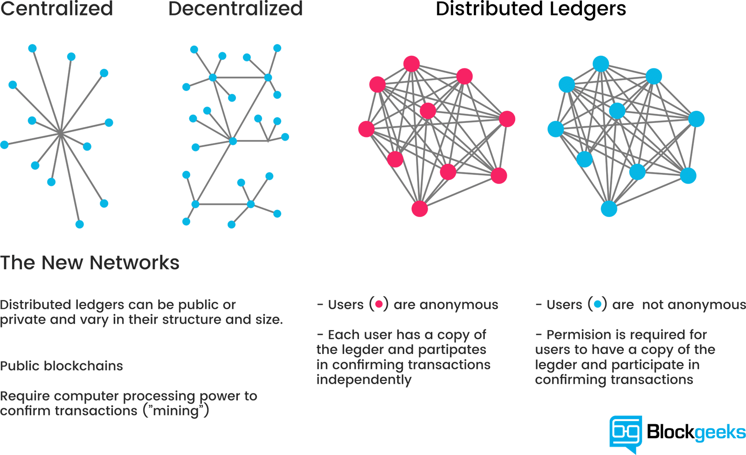

## A second-level network

With blockchain technology, the web gains a new layer of functionality.

Already, users can transact directly with one another — Bitcoin transactions in 2016 averaged over $200,000 US per day. With the added security brought by the blockchain new internet business are on track to unbundle the traditional institutions of finance.

Goldman Sachs believes that blockchain technology holds great potential especially to optimize clearing and settlements, and could represent global savings of up to $6bn per year.



**“2017 will be a pivotal year for blockchain tech. Many of the startups in the space will either begin generating revenue – via providing products the market demands/values – or vaporize due to running out of cash. In other words, 2017 should be the year where there is more implementation of products utilizing blockchain tech, and less talk about blockchain tech being the magical pixie dust that can just be sprinkled atop everything. Of course, from a customers viewpoint, this will not be obvious as blockchain tech should dominantly be invisible – even as its features and functionality improve peoples’/business’ lives. I personally am familiar with a number of large-scale blockchain tech use cases that are launching soon/2017. This implementation stage, which 2017 should represent, is a crucial step in the larger adoption of blockchain tech, as it will allow skeptics to see the functionality, rather than just hear of its promise.”**

–  [George Howard](http://www.forbes.com/sites/georgehoward/), Associate Professor Brown University, Berklee College of Music and Founder of George Howard Strategic

## The Blockchain a New Web 3.0?

The blockchain gives internet users the ability to create value and authenticates digital information. What will new business applications result?

#### [Smart contracts](http://blockgeeks.com/guides/smart-contracts/)

Distributed ledgers enable the coding of simple contracts that will execute when specified conditions are met. [Ethereum](http://blockgeeks.com/guides/what-is-ethereum/) is an open source blockchain project that was built specifically to realize this possibility. Still, in its early stages, Ethereum has the potential to leverage the usefulness of blockchains on a truly world-changing scale.

At the technology’s current level of development, smart contracts can be programmed to perform simple functions. For instance, a derivative could be paid out when a financial instrument meets certain benchmark, with the use of blockchain technology and Bitcoin enabling the payout to be automated.

#### The sharing economy

With companies like Uber and AirBnB flourishing, the sharing economy is already a proven success. Currently, however, users who want to hail a ride-sharing service have to rely on an intermediary like Uber. By enabling peer-to-peer payments, the blockchain opens the door to direct interaction between parties — a truly decentralized sharing economy results.

An early example, [OpenBazaar](https://openbazaar.org/) uses the blockchain to create a peer-to-peer eBay. Download the app onto your computing device, and you can transact with OpenBazzar vendors without paying transaction fees. The “no rules” ethos of the protocol means that personal reputation will be even more important to business interactions than it currently is on eBay.

#### Crowdfunding

Crowdfunding initiatives like Kickstarter and Gofundme are doing the advance work for the emerging peer-to-peer economy. The popularity of these sites suggests people want to have a direct say in product development. Blockchains take this interest to the next level, potentially creating crowd-sourced venture capital funds.

In 2016, one such experiment, the [Ethereum](http://blockgeeks.com/guides/what-is-ethereum-a-step-by-step-beginners-guide/)-based DAO (Decentralized Autonomous Organization), raised an astonishing $200 million USD in just over two months. Participants purchased “DAO tokens” allowing them to vote on smart contract venture capital investments (voting power was proportionate to the number of DAO they were holding). A subsequent hack of project funds proved that the project was launched without proper due diligence, with disastrous consequences.  Regardless, the DAO experiment suggests the blockchain has the potential to usher in “a new paradigm of economic cooperation.”

#### Governance

By making the results fully transparent and publicly accessible, distributed database technology could bring full transparency to elections or any other kind of poll taking. Ethereum-based smart contracts help to automate the process.

The app, Boardroom, enables organizational decision-making to happen on the blockchain. In practice, this means company governance becomes fully transparent and verifiable when managing digital assets, equity or information.

#### Supply chain auditing

Consumers increasingly want to know that the ethical claims companies make about their products are real. Distributed ledgers provide an easy way to certify that the backstories of the things we buy are genuine. Transparency comes with blockchain-based timestamping of a date and location — on ethical diamonds, for instance — that corresponds to a product number.

The UK-based Provenance offers supply chain auditing for a range of consumer goods. Making use of the Ethereum blockchain, a Provenance pilot project ensures that fish sold in Sushi restaurants in Japan has been sustainably harvested by its suppliers in Indonesia.

#### File storage

Decentralizing file storage on the internet brings clear benefits. Distributing data throughout the network protects files from getting hacked or lost.

Inter Planetary File System (IPFS) makes it easy to conceptualize how a distributed web might operate. Similar to the way a bittorrent moves data around the internet, IPFS gets rid of the need for centralized client-server relationships (i.e., the current web). An internet made up of completely decentralized websites has the potential to speed up file transfer and streaming times. Such an improvement is not only convenient. It’s a necessary upgrade to the web’s currently overloaded content-delivery systems.

#### Prediction markets

The crowdsourcing of predictions on event probability is proven to have a high degree of accuracy. Averaging opinions cancels out the unexamined biases that distort judgment. Prediction markets that payout according to event outcomes are already active. Blockchains are a “wisdom of the crowd” technology that will no doubt find other applications in the years to come.

Still, in Beta, the prediction market application [Augur](https://www.augur.net/)makes share offerings on the outcome of real-world events. Participants can earn money by buying into the correct prediction. The more shares purchased in the correct outcome, the higher the payout will be. With a small commitment of funds (less than a dollar), anyone can ask a question, create a market based on a predicted outcome, and collect half of all transaction fees the market generates.

#### Protection of intellectual property

As is well known, digital information can be infinitely reproduced — and distributed widely thanks to the internet. This has given web users globally a goldmine of free content. However, copyright holders have not been so lucky, losing control over their intellectual property and suffering financially as a consequence. Smart contracts can protect copyright and automate the sale of creative works online, eliminating the risk of file copying and redistribution.

Mycelia uses the blockchain to create a peer-to-peer music distribution system. Founded by the UK singer-songwriter Imogen Heap, Mycelia enables musicians to sell songs directly to audiences, as well as license samples to producers and divvy up royalties to songwriters and musicians — all of these functions being automated by smart contracts. The capacity of blockchains to issue payments in fractional cryptocurrency amounts (micropayments) suggests this use case for the blockchain has a strong chance of success.

#### [Internet of Things (IoT)](http://blockgeeks.com/5-incredible-blockchain-iot-applications/)

What is the IoT? The network-controlled management of certain types of electronic devices — for instance, the monitoring of air temperature in a storage facility. Smart contracts make the automation of remote systems management possible. A combination of software, sensors, and the network facilitates an exchange of data between objects and mechanisms. The result increases system efficiency and improves cost monitoring.

The biggest players in manufacturing, tech and telecommunications are all vying for IoT dominance. Think Samsung, IBM and AT&T. A natural extension of existing infrastructure controlled by incumbents, IoT applications will run the gamut from predictive maintenance of mechanical parts to data analytics, and mass-scale automated systems management.

#### Neighbourhood Microgrids

Blockchain technology enables the buying and selling of the renewable energy generated by neighborhood microgrids. When solar panels make excess energy, Ethereum-based smart contracts automatically redistribute it. Similar types of smart contract automation will have many other applications as the IoT becomes a reality.

Located in Brooklyn, [Consensys](https://consensys.net/about/) is one of the foremost companies globally that is developing a range of applications for Ethereum. One project they are partnering on is Transactive Grid, working with the distributed energy outfit, LO3. A prototype project currently up and running uses Ethereum smart contracts to automate the monitoring and redistribution of microgrid energy. This so-called “intelligent grid” is an early example of IoT functionality.

#### Identity management

There is a definite need for better identity management on the web. The ability to verify your identity is the lynchpin of financial transactions that happen online. However, remedies for the security risks that come with web commerce are imperfect at best. Distributed ledgers offer enhanced methods for proving who you are, along with the possibility to digitize personal documents. Having a secure identity will also be important for online interactions — for instance, in the sharing economy. A good reputation, after all, is the most important condition for conducting transactions online.

Developing digital identity standards is proving to be a highly complex process. Technical challenges aside, a universal online identity solution requires cooperation between private entities and government. Add to that the need to navigate legal systems in different countries and the problem becomes exponentially difficult. E-Commerce on the internet currently relies on the SSL certificate (the little green lock) for secure transactions on the web. Netki is a startup that aspires to create an SSL standard for the blockchain. Having recently announced a $3.5 million seed round, Netki expects a product launch in early 2017.

#### AML and KYC

Anti-money laundering (AML) and know your customer (KYC) practices have a strong potential for being adapted to the blockchain. Currently, financial institutions must perform a labour intensive multi-step process for each new customer. KYC costs could be reduced through cross-institution client verification, and at the same time increase monitoring and analysis effectiveness.

Startup Polycoin has an AML/KYC solution that involves analysing transactions. Those transactions identified as being suspicious are forwarded on to compliance officers. Another startup Tradle is developing an application called Trust in Motion (TiM). Characterized as an “Instagram for KYC”, TiM allows customers to take a snapshot of key documents (passport, utility bill, etc.). Once verified by the bank, this data is cryptographically stored on the blockchain.

#### Data management

Today, in exchange for their personal data people can use social media platforms like Facebook for free. In future, users will have the ability to manage and sell the data their online activity generates. Because it can be easily distributed in small fractional amounts, Bitcoin — or something like it — will most likely be the currency that gets used for this type of transaction.

The MIT project Enigma understands that user privacy is the key precondition for creating of a personal data marketplace. Enigma uses cryptographic techniques to allow individual data sets to be split between nodes, and at the same time run bulk computations over the data group as a whole. Fragmenting the data also makes Enigma scalable (unlike those blockchain solutions where data gets replicated on every node). A Beta launch is promised within the next six months.

#### Land title registration

As Publicly-accessible ledgers, blockchains can make all kinds of record-keeping more efficient. Property titles are a case in point. They tend to be susceptible to fraud, as well as costly and labour intensive to administer.

A number of countries are undertaking blockchain-based land registry projects. Honduras was the first government to announce such an initiative in 2015, although the current status of that project is unclear. This year, the Republic of Georgia cemented a deal with the Bitfury Group to develop a blockchain system for property titles. Reportedly, Hernando de Soto, the high-profile economist and property rights advocate, will be advising on the project. Most recently, Sweden announced it was experimenting with a blockchain application for property titles.

#### Stock trading

The potential for added efficiency in share settlement makes a strong use case for blockchains in stock trading. When executed peer-to-peer, trade confirmations become almost instantaneous (as opposed to taking three days for clearance). Potentially, this means intermediaries — such as the clearing house, auditors and custodians — get removed from the process.

Numerous stock and commodities exchanges are prototyping blockchain applications for the services they offer, including the ASX (Australian Securities Exchange), the Deutsche Börse (Frankfurt’s stock exchange) and the JPX (Japan Exchange Group). Most high profile because the acknowledged first mover in the area, is the Nasdaq’s Linq, a platform for private market trading (typically between pre-IPO startups and investors). A partnership with the blockchain tech company Chain, Linq announced the completion of it its first share trade in 2015. More recently, Nasdaq announced the development of a trial blockchain project for proxy voting on the Estonian Stock Market.

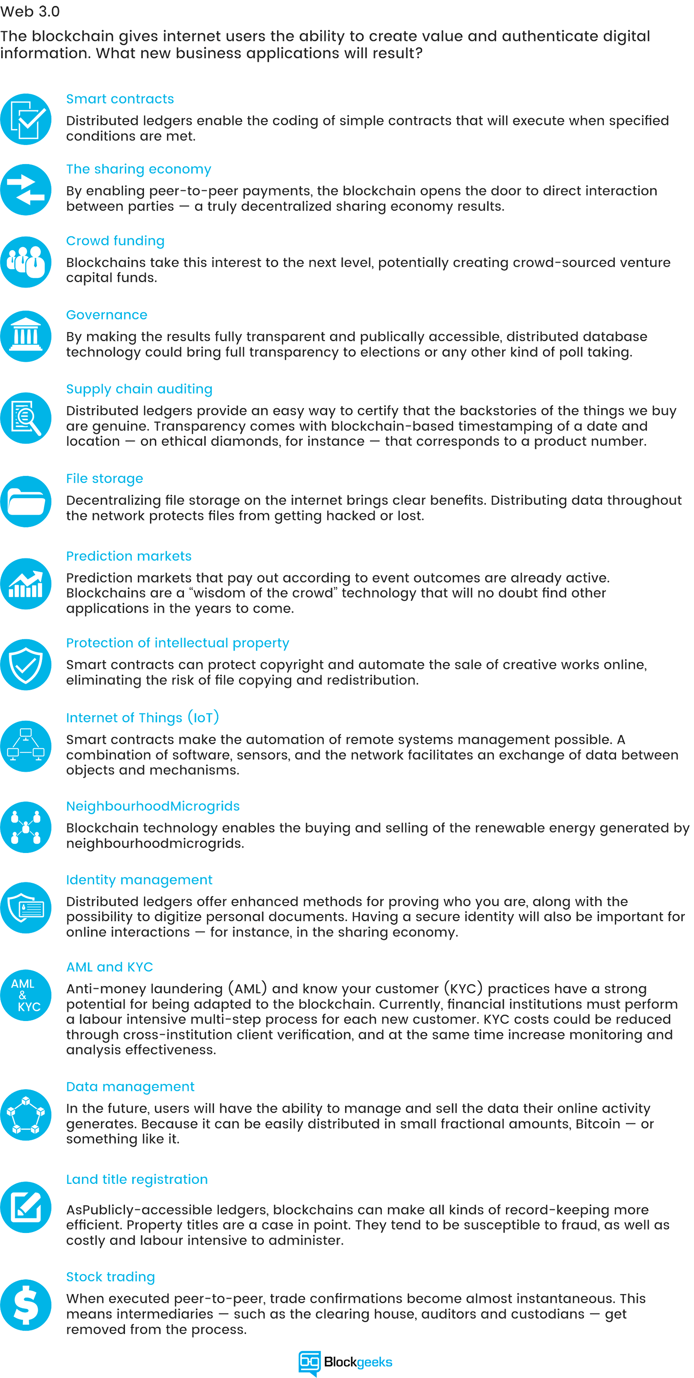

***“2016 was the year in which blockchain theory achieved general acceptance, but remained in theory, with the big players lingering around the hoop waiting to see who would take the first shot. As the year comes to an end, blockchain technology is tantalizingly close to turning the corner and entering the realm of small-scale commercial ability. Overall, 2017 is going to be the year of the very well-considered and well-funded proof of concept, with a few projects achieving revenue positive status. Venture investment is going to continue to be substantial but less than we saw in 2016 and 2015. I’d predict one or two exits by acquisition.”***

– [Judd Bagley](http://juddbagley.com/)  Director of Communications at [Overstock.com](https://www.overstock.com/) and Chief Evangelist at [t0.com](https://t0.com/)

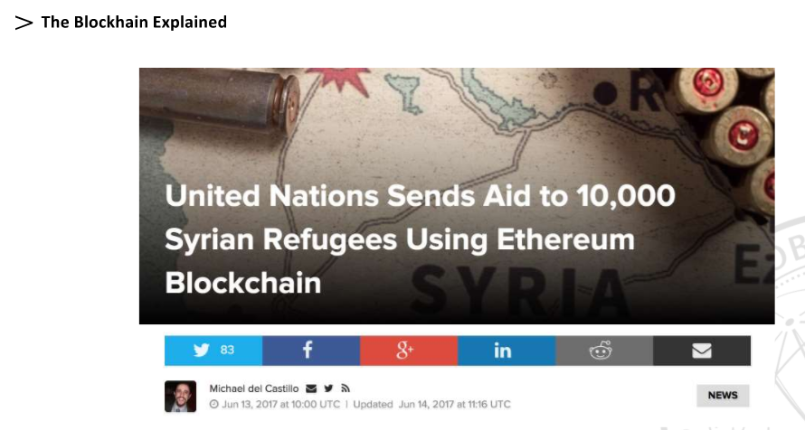

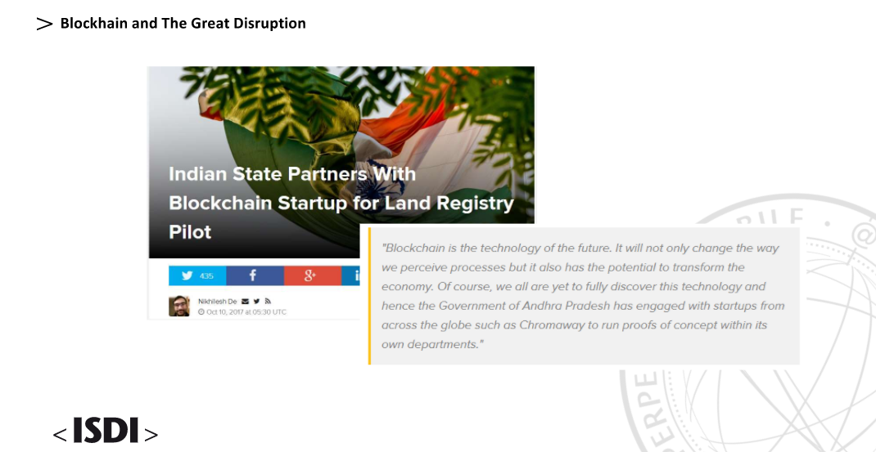

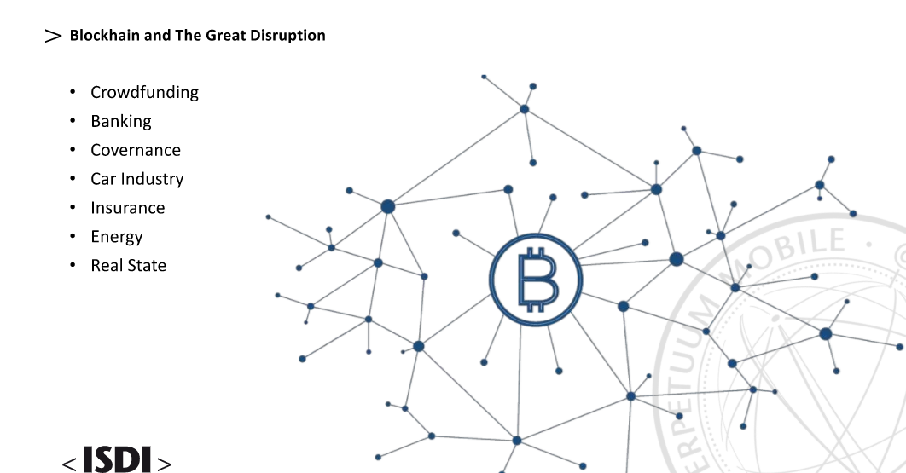



Misconception about Blockchain: <https://www.itproportal.com/features/breaking-down-blockchain-10-common-misconceptions/>

### Immutability

Many believe that blockchain records can never be hacked or altered. The reality is, no system is ever completely secure. For example, any person or group within the bitcoin network is capable of gathering enough mining resources to take control of the blockchain. Although extremely unlikely, as they would require a mining capacity larger than the rest of the network, it is theoretically possible.This is called a ’51 per cent attack’. It is generally understood that the larger and more distributed a network is, the less likely that this is to happen and, ultimately, the more secure it is. In truth, the only real promise a blockchain makes is to catch any unauthorised changes made to the records of applications that choose to build on top of it.

### File storage

The misconception that blockchains work like the cloud is most likely due to their intangibility. A blockchain cannot store physical information such as a word or pdf file but instead provides a proof-of-existence. In essence, the blockchain holds code that certifies the existence of a particular document. Like a traditional ledger, it is a record of transactions.

### Smart contract = legal contract

Despite the word ‘contract’ in the name, smart contracts are not in fact contracts. A smart contract is a software code written into a program which follows instruction written within an agreement between parties. They are basically a list of if/then statements that operate automatically when a certain condition is met, ie. if x happens, then y must be enacted. They are not legally binding and can only exist within the blockchain. In this respect, they can be considered a tool rather than a contract.

Tutorial:

\*Blockchain for dummies

IBM book is good

\*Lisk project -> application to build. Creating smart contract for everyone <https://lisk.io/>

IOTA.org -> use cases

[coinmarketcap.com](http://coinmarketcap.com/)

ada project

Look at

Uses Case

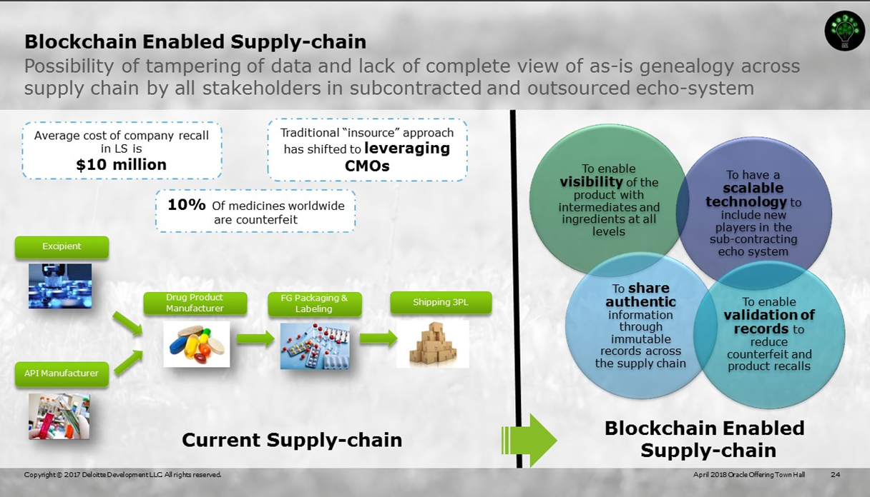

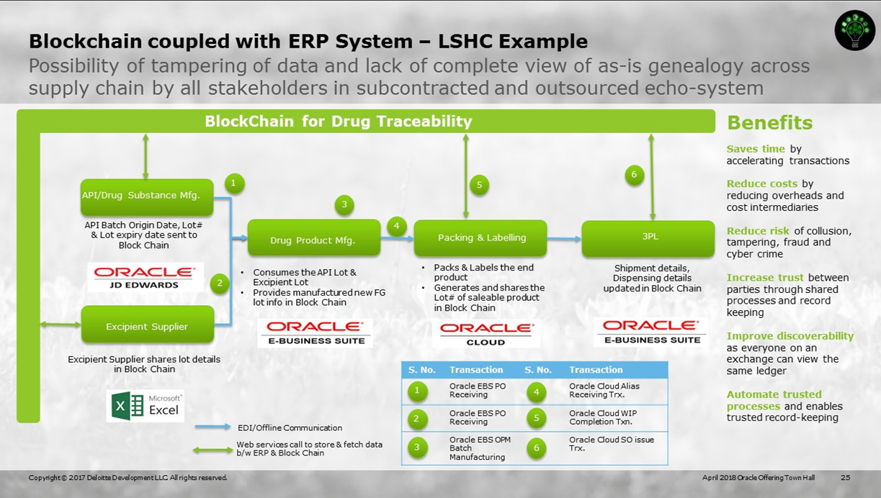

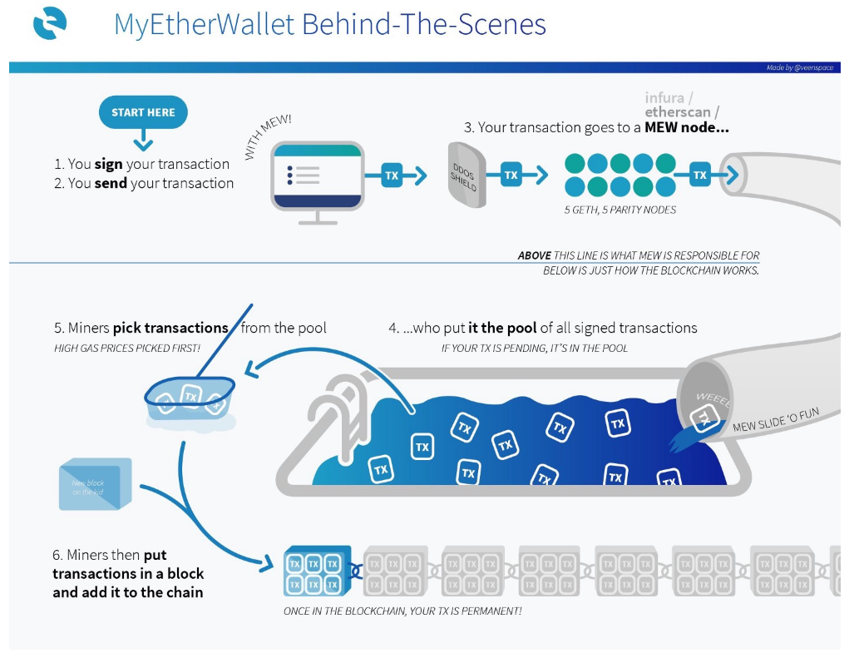

CB Insight

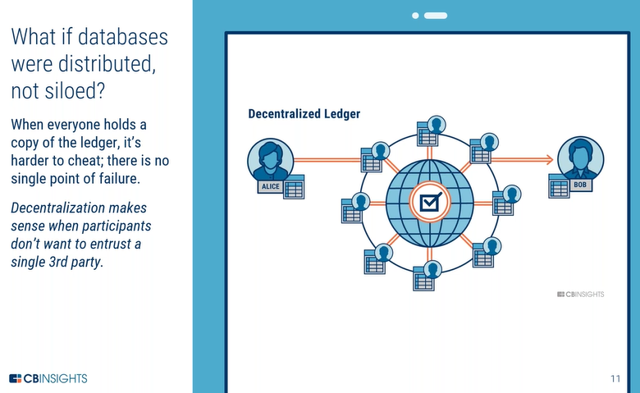

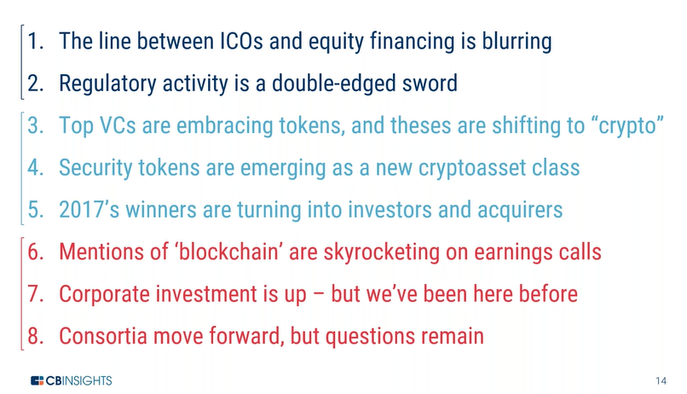

Token and ICO –

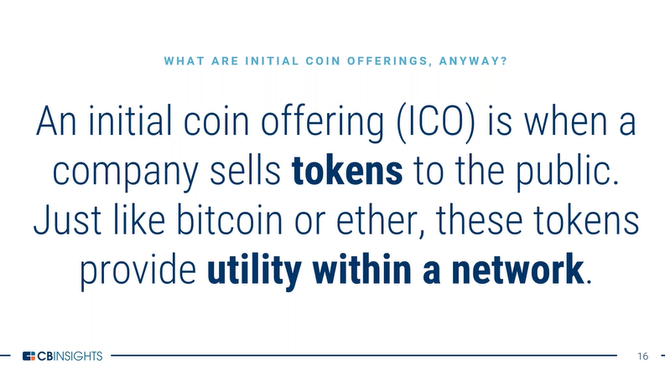

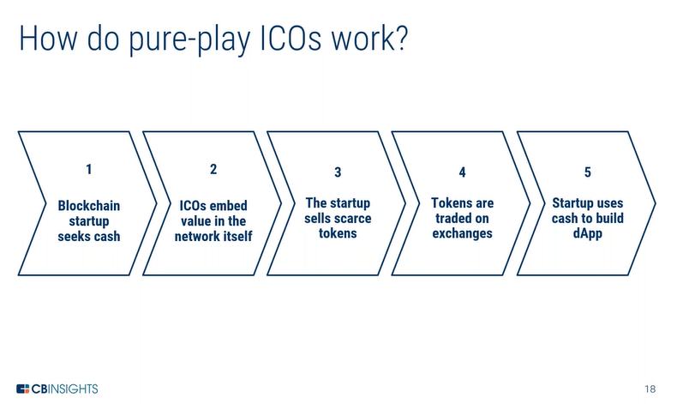

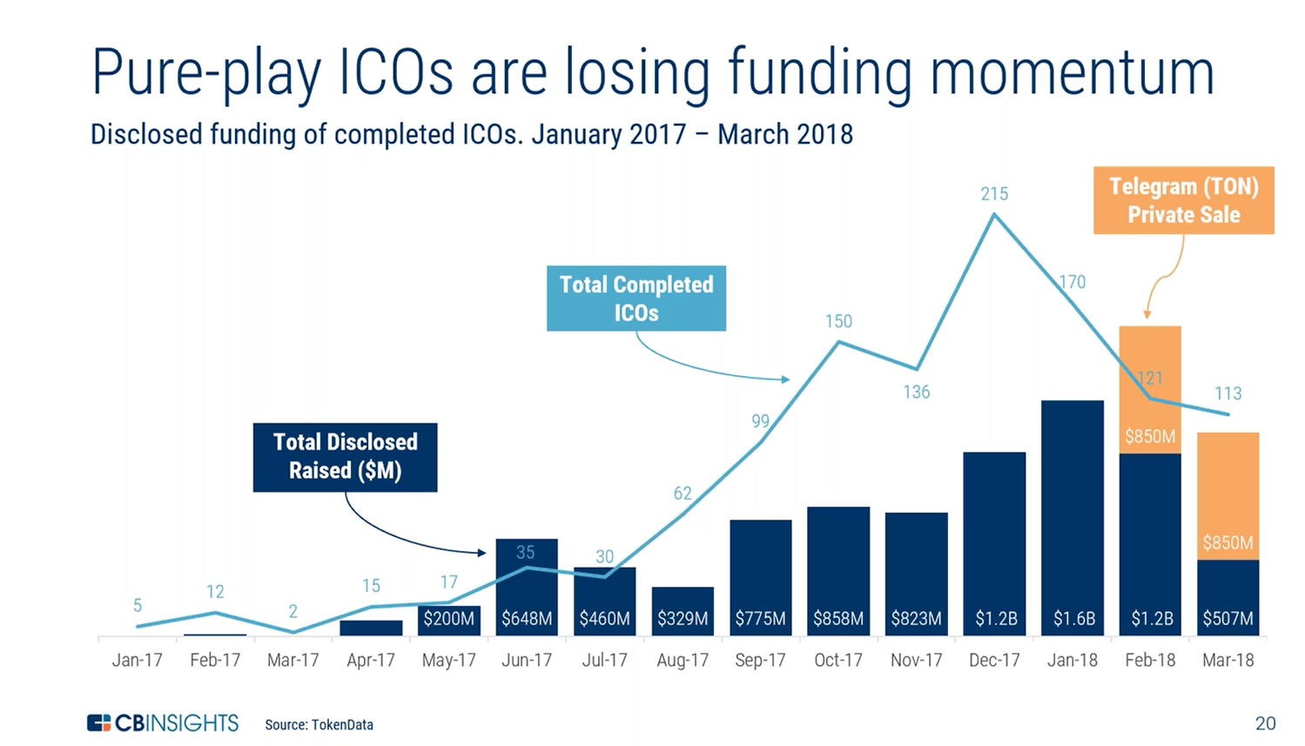

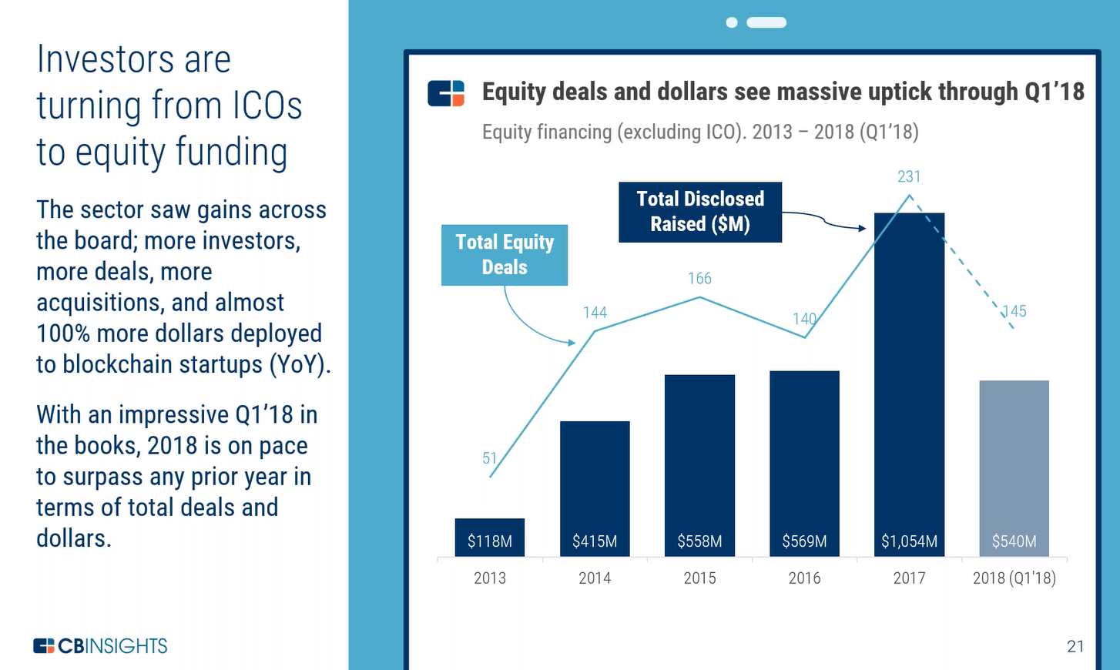

More dollars in Pre-sale and Post sale than ICO

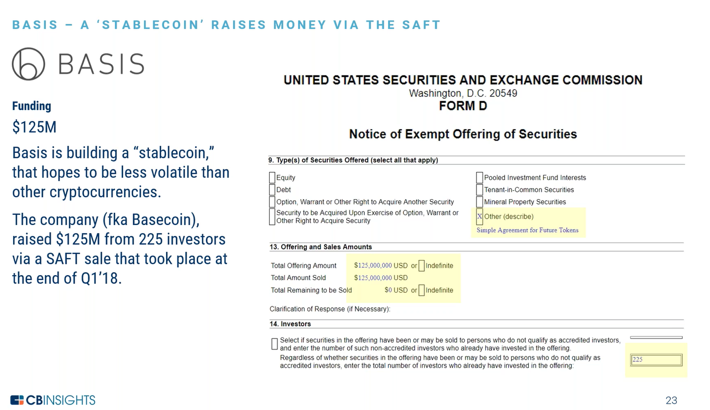

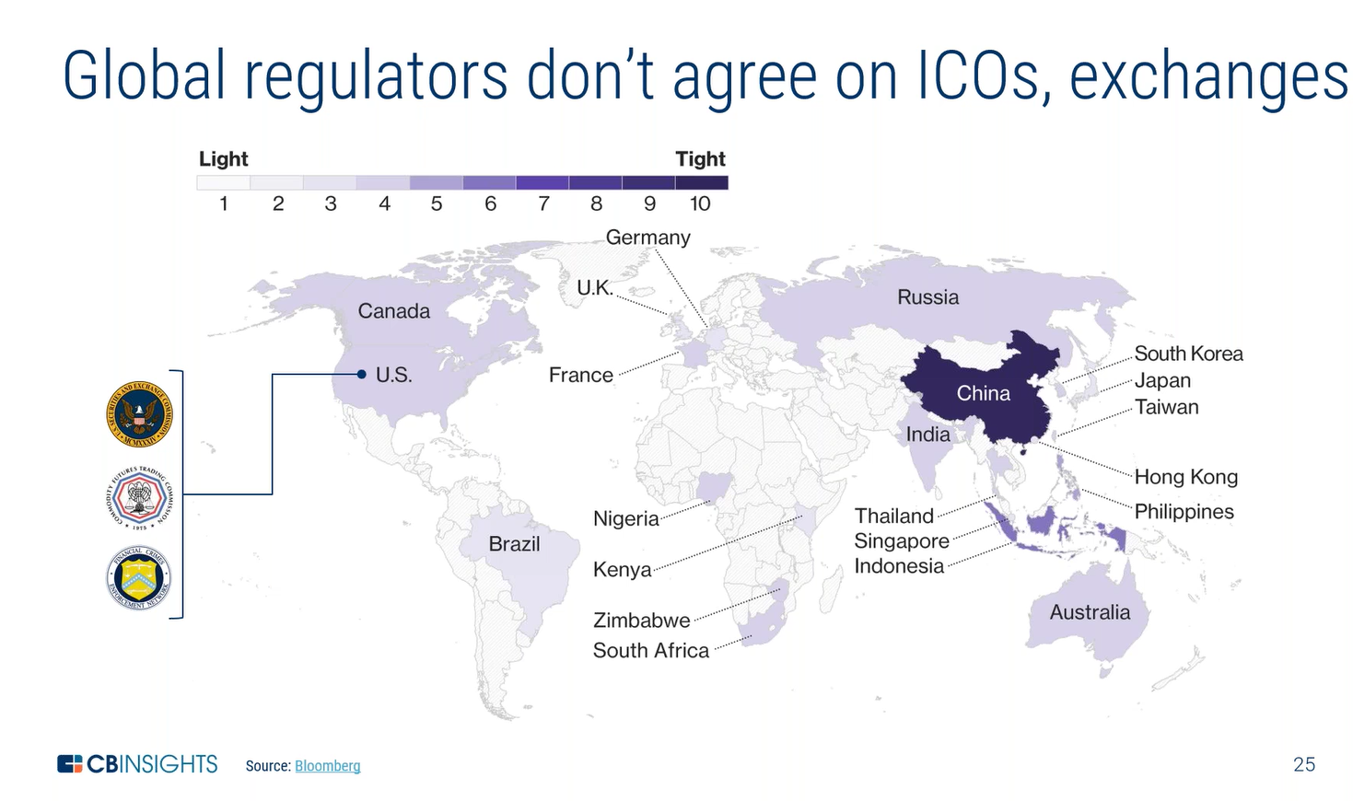

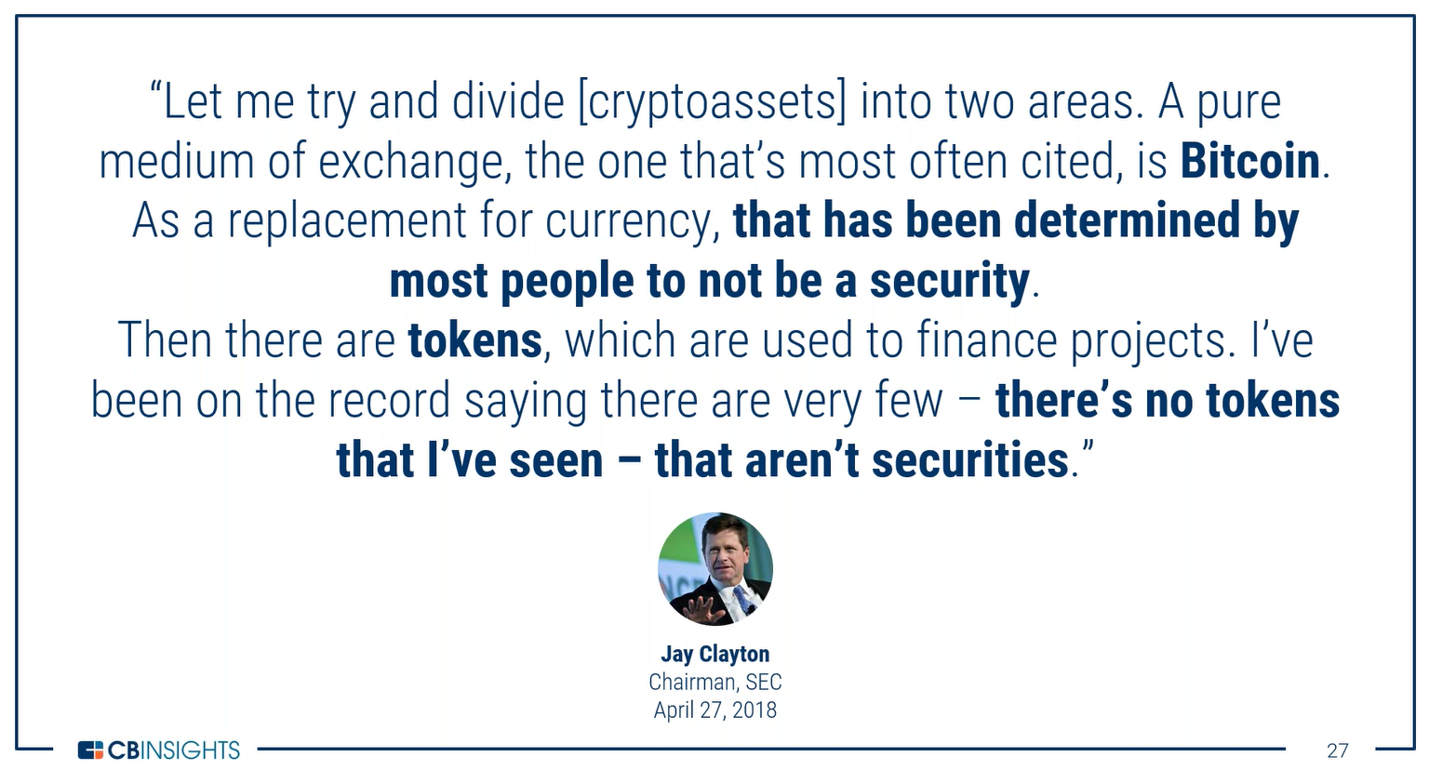

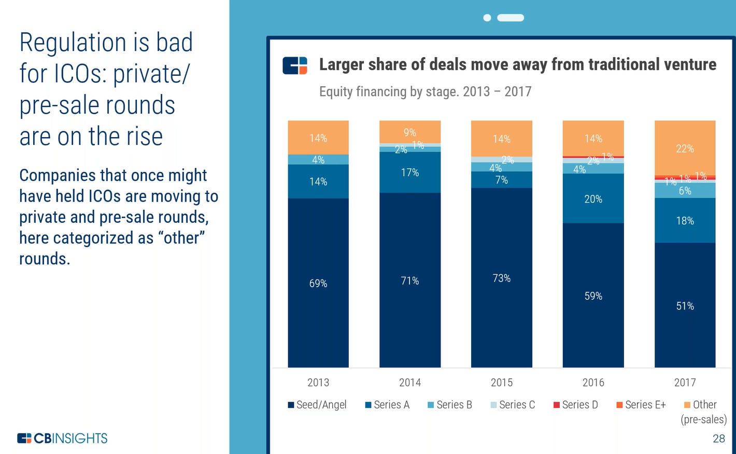

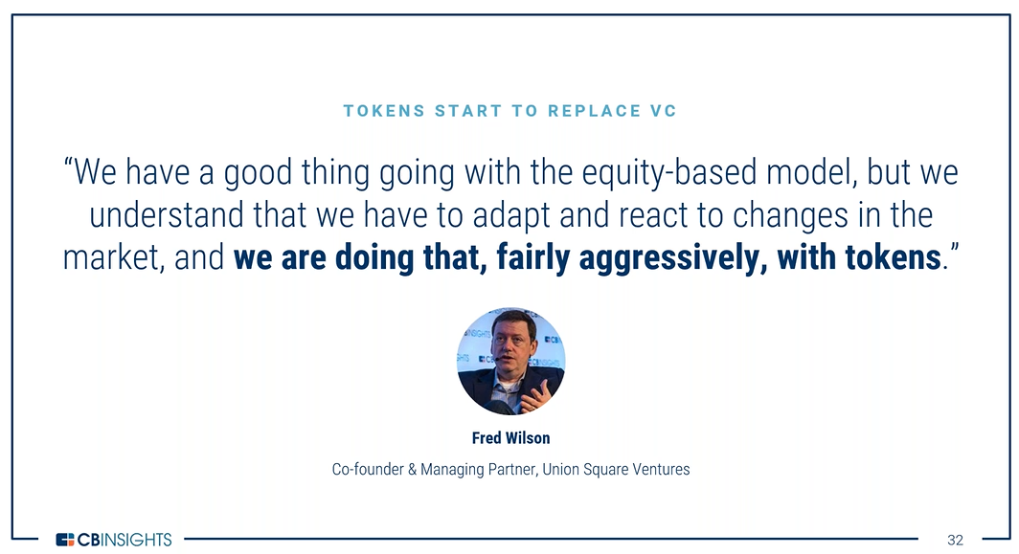

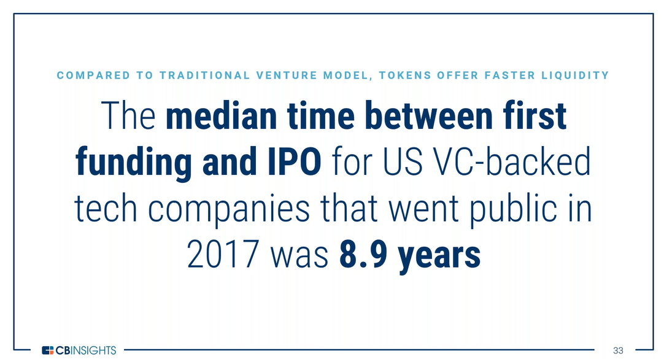

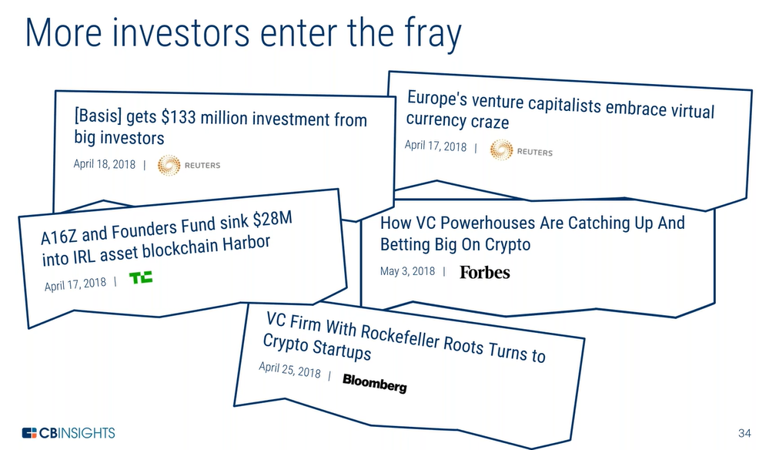

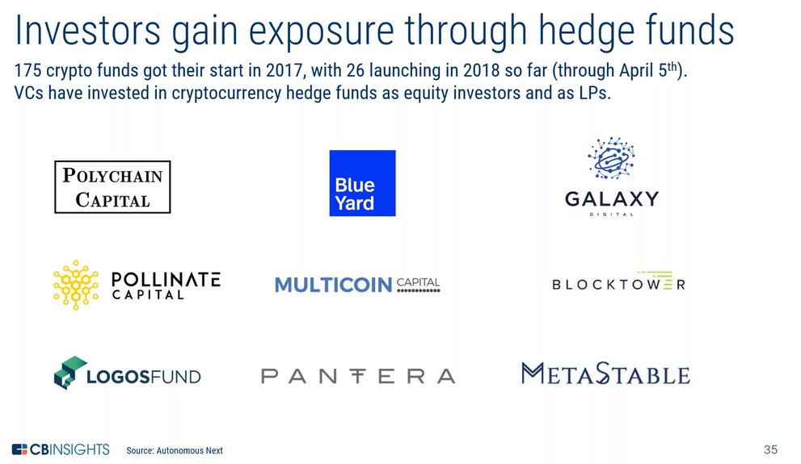

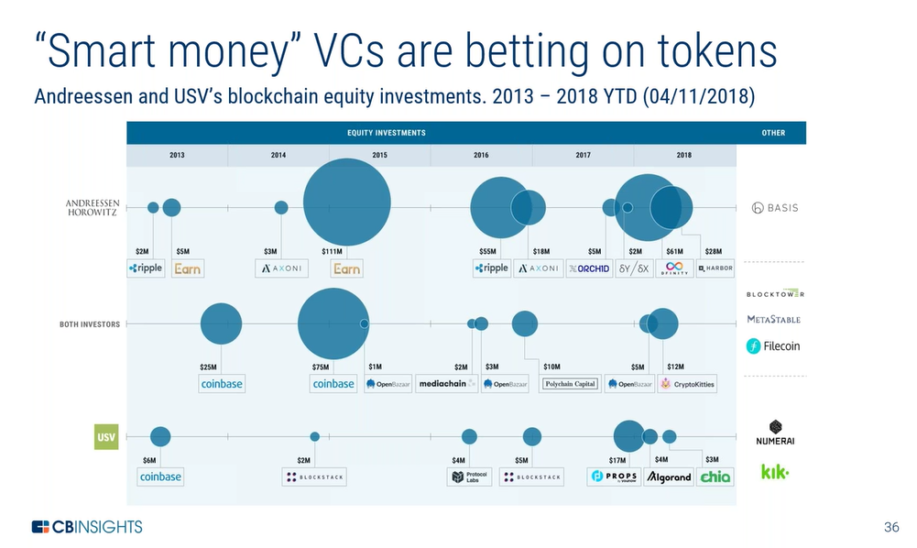

Security Tokens or Tokenized Securities:

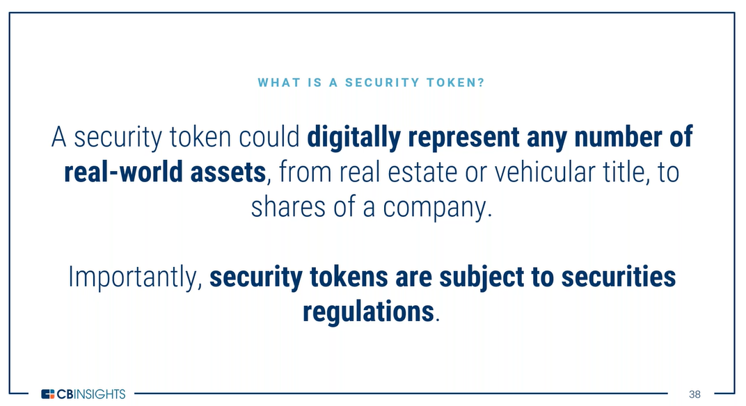

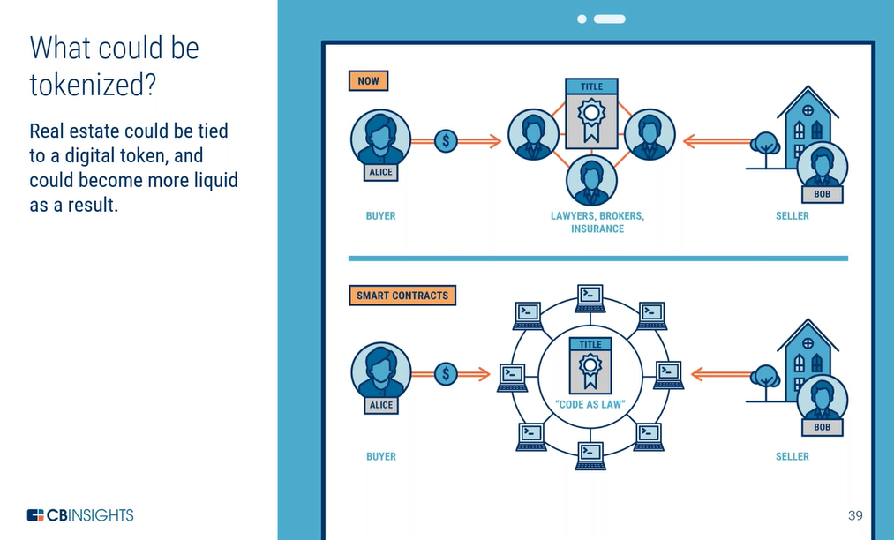

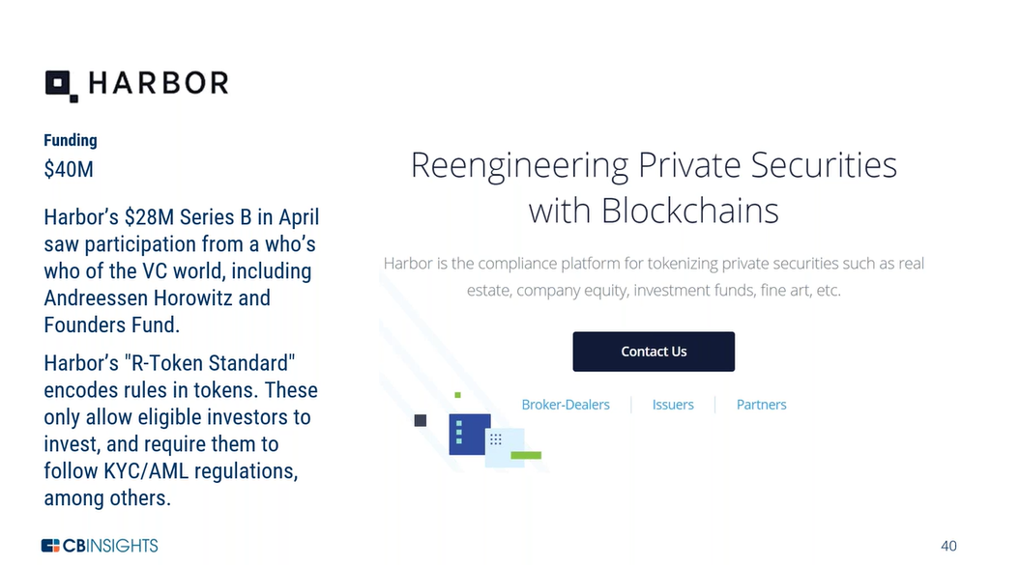

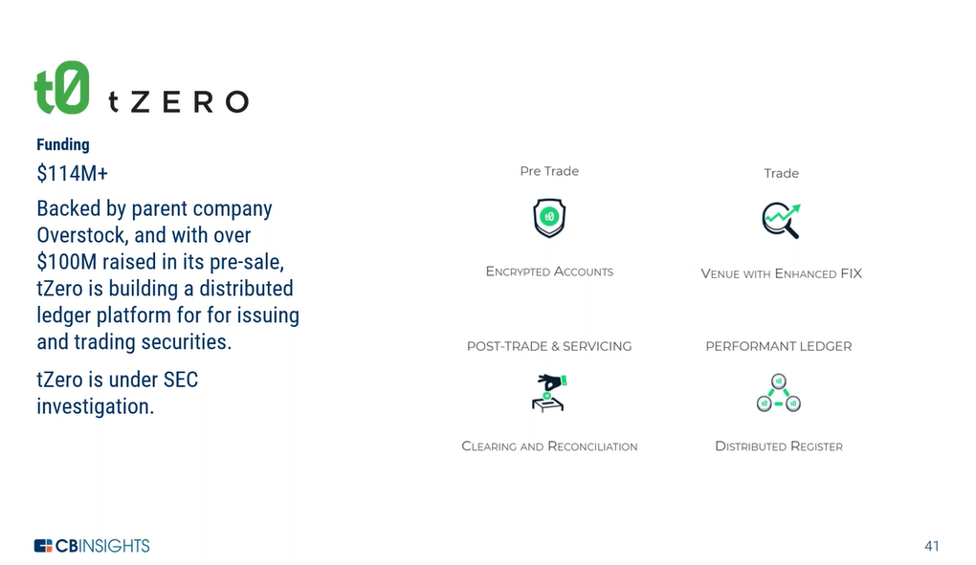

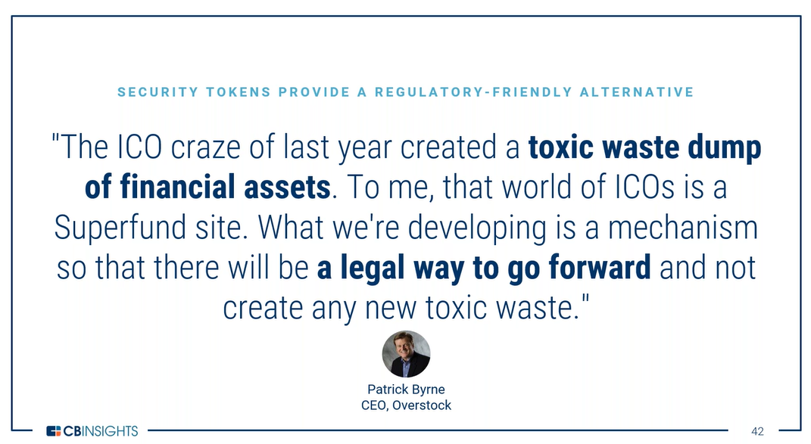

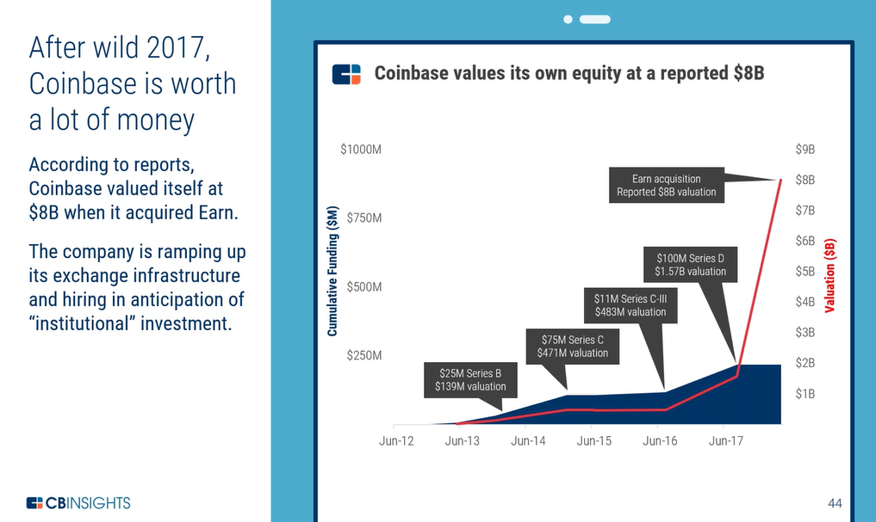

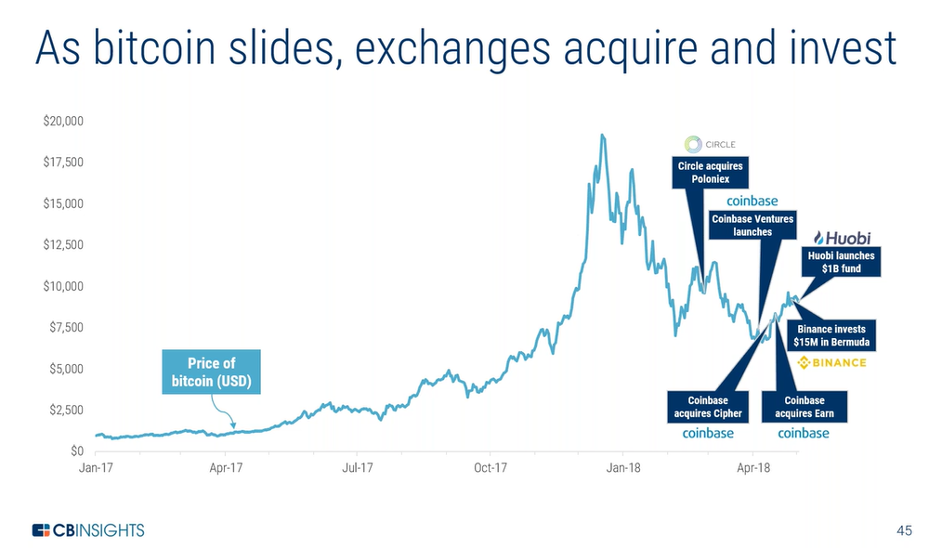

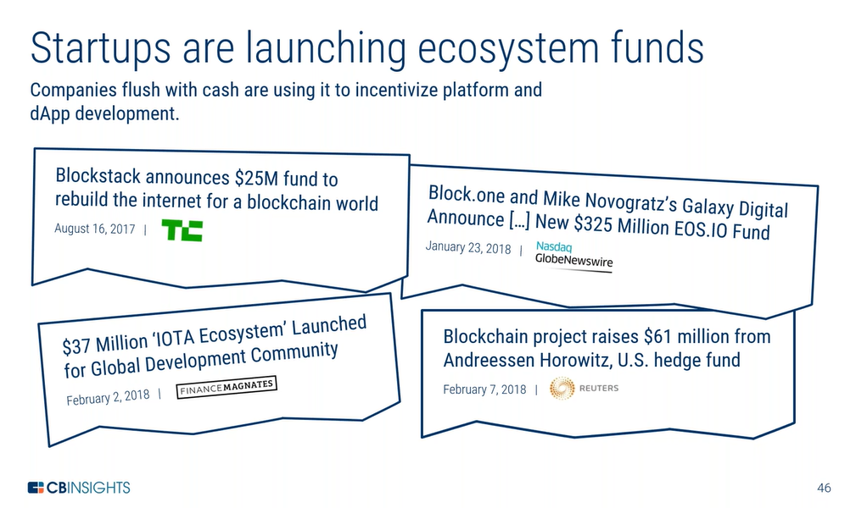

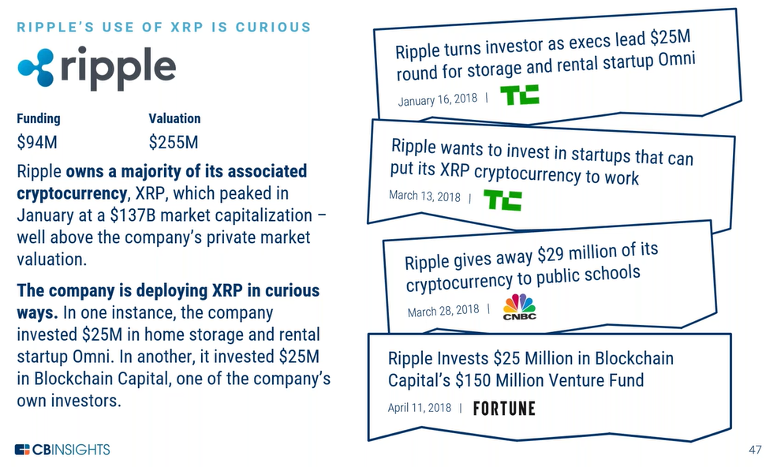

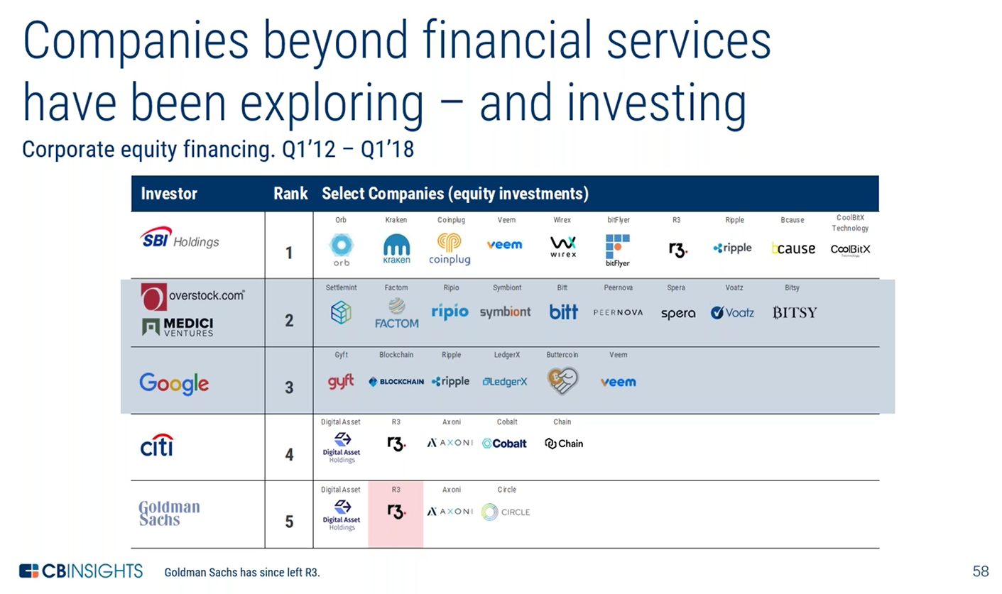

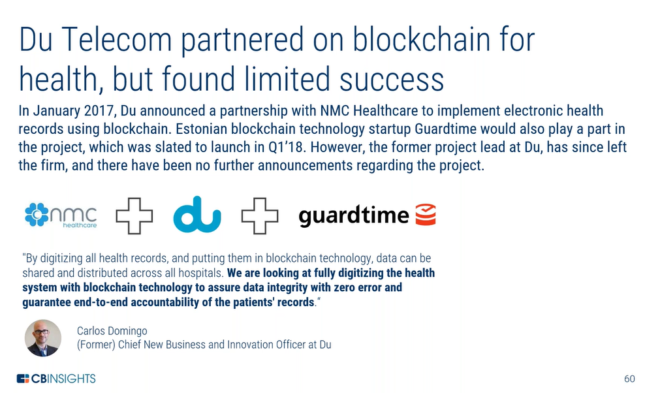

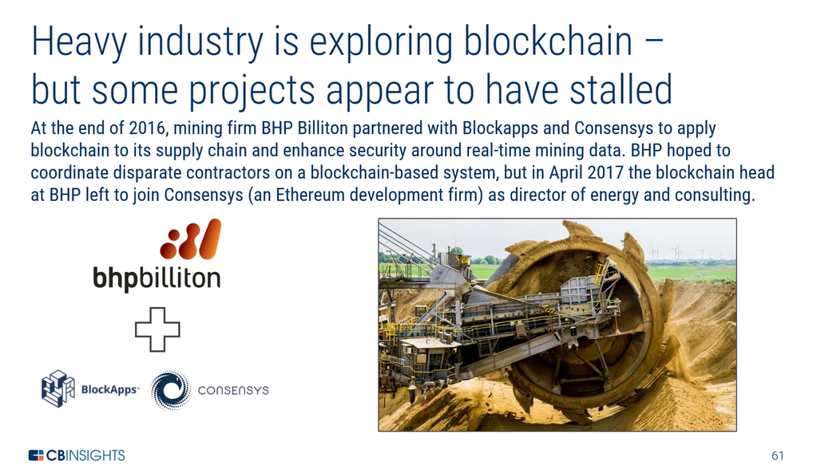

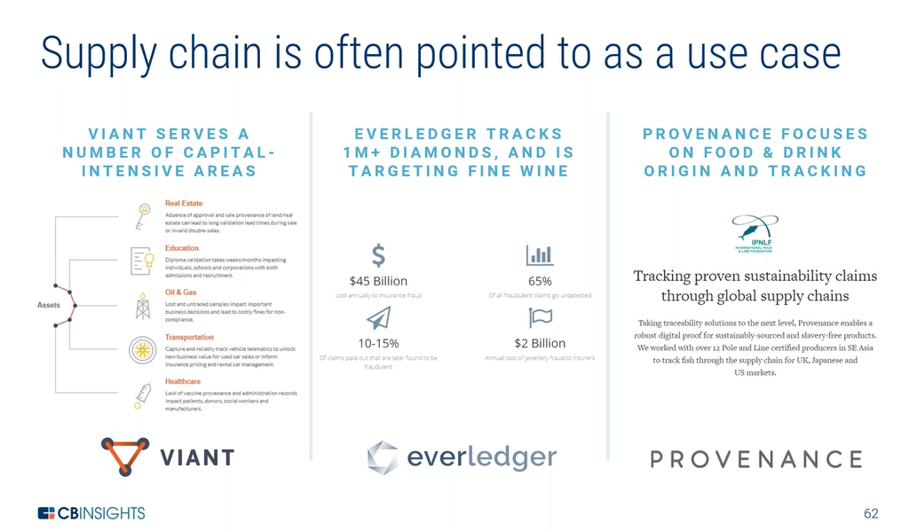

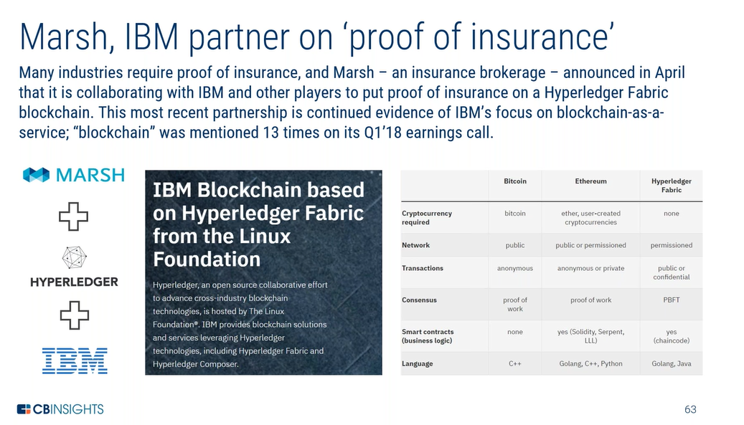

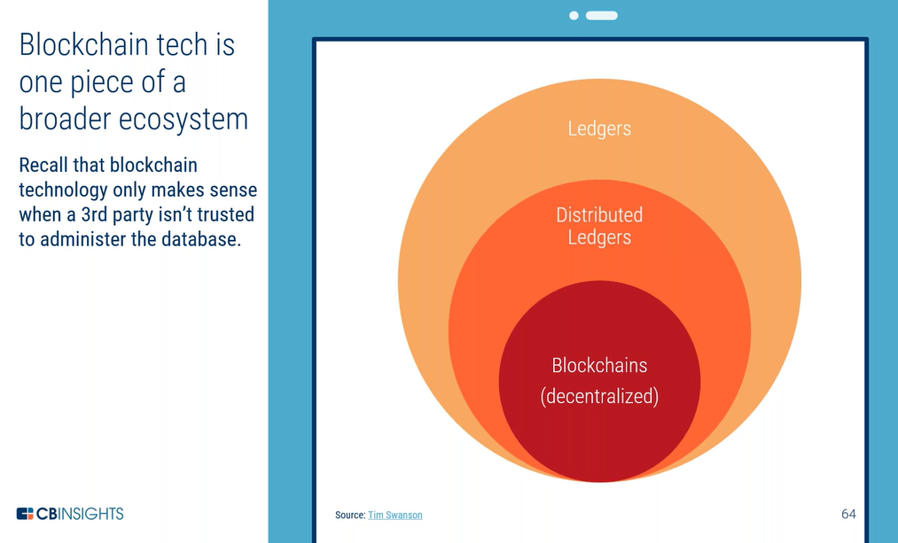

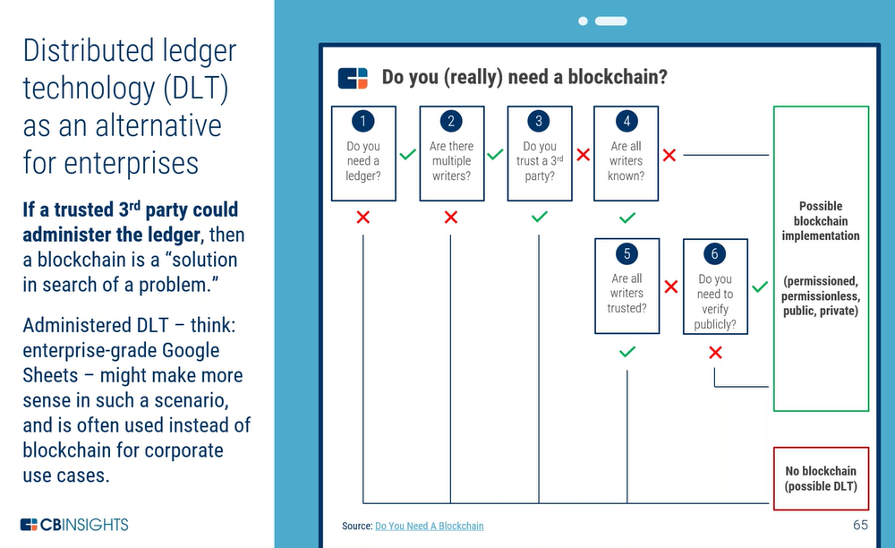

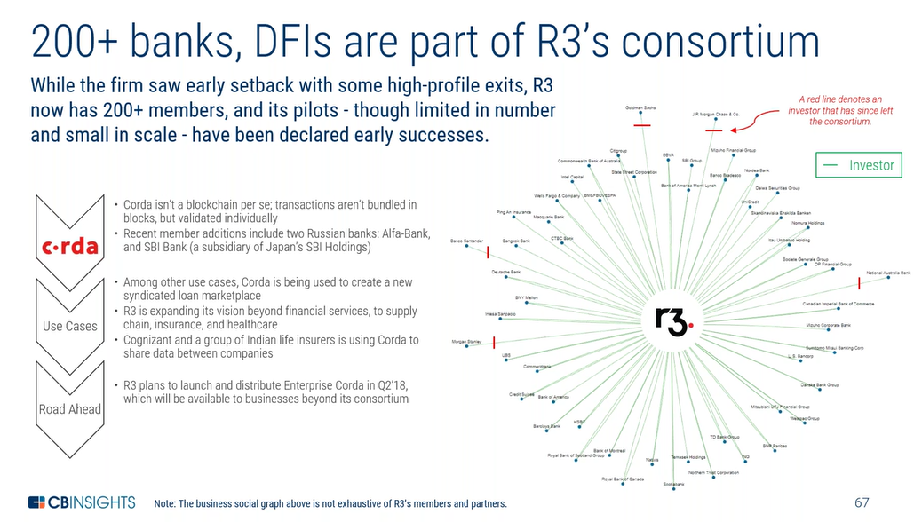

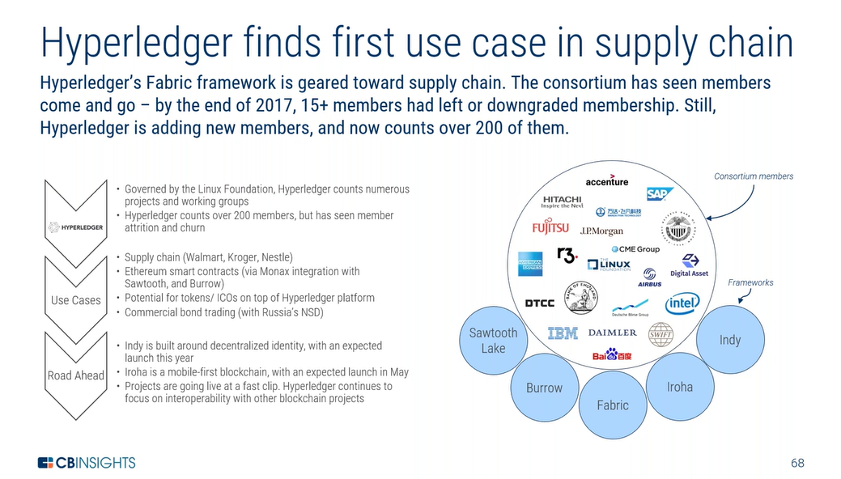

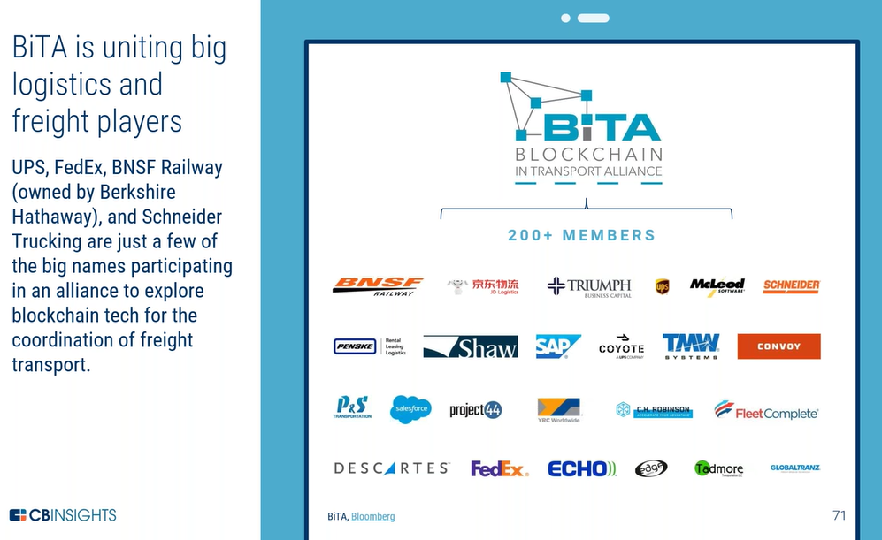

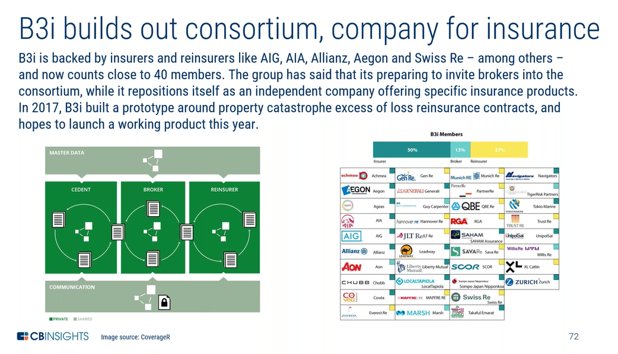

**Blockchain Business models:**

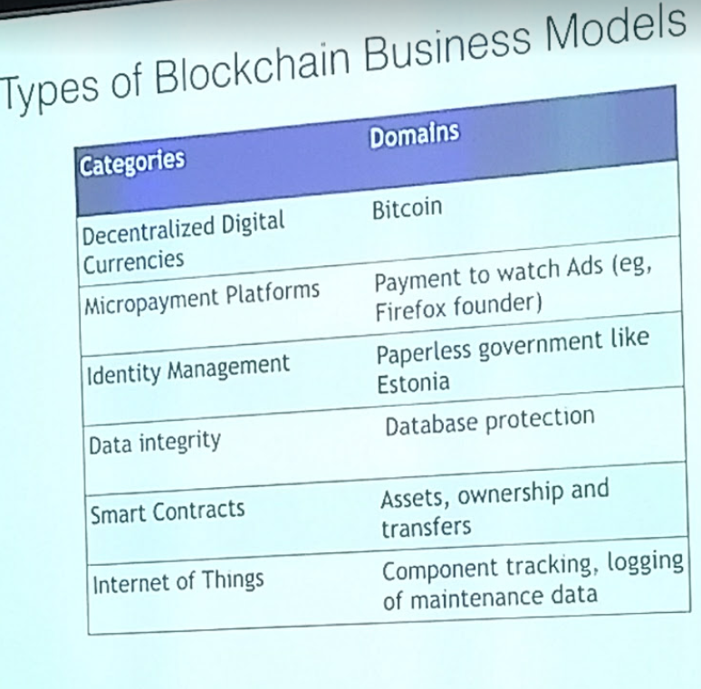

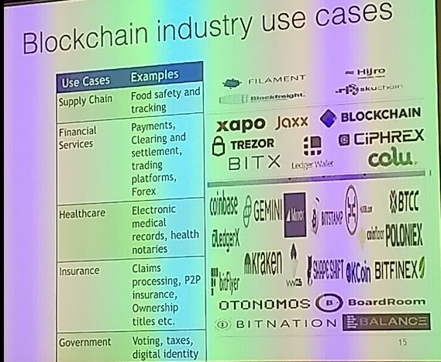

**Car history tracking –**

**Property history tracking –**

**Legal document tracking –**

**Entertainment – artist getting paid on views on YouTube**

Blockchain solves a number of challenges by integrating and con­verging a list of critical technologies and services. These include:

• Large database technology

• Distributed/Decentralized account­ing ledgers that use technology to track every detail of a transaction

• Cryptography to protect digital transactions against hacking

• High speed Internet networking and connectivity to virtually any device

• Internet of Things (IoT) where almost any device can be network addressable and enabled (machines to machines communications)

• Mobility of data, digital applications and convenience of computing, and

• Open systems that rely upon more transparency and collaboration, vice monolithic and proprietary walls-of-separation.

Blockchain makes it easier for artists to receive compensation while improving the way consumers access media. Blockchain as a platform to protect artist rights –

• Enable Smart Contracts

• Establish transparent person-to-person transactions

• Establish a reputation system

• Promote dynamic and efficient pricing

• Allow micrometering and micromonetizing

Particularly for the media indus­tries, that has been heavily affected by the ubiquitous availability and the subsequent “commoditization” of content and been undermined by widespread piracy of intel­lectual property (IP). Media users are largely ac­customed to having free access to a wide variety of content, and most of them are still reluctant to pay subscription fees for “premium” content behind paywalls. In addition, all media segments have suffered significantly from digitization, since content can be copied and distributed easily and without loss of quality. So far, the introduction of Digital Rights Management systems has not substantially reduced copyright infringements. It gives listeners access to music on whatever player they choose, while ensuring that artists receive as much revenue as possible. Blockchain could also make it easier to access media by bypassing some of the geographical limitations on services like Netflix and Spotify. A decentralized ledger isn’t kept in any particular location, so the days of regional broadcasting contacts might be com­ing to an end.

In fact, if media companies embrace the efficiencies in rights management, payment collection, and additional distribution channels enabled by Blockchain, they can spend more time focusing on what they’re relatively good at making and marketing content.

The Future of Entertainment Industry of the 21st century is Blockchain technology, an innovation that can digitally support a dynamic and connected global network of content producers, distributors and audiences.

The entertainment industry has grown exponentially over the years. As a result, a status quo has become established in which company executives and the top tier of artists make enormous sums of money. The internet has already started to change things, allowing a much broader swathe of creators to find an audience. However, big problems still exist in terms of revenue, with distribution services and piracy both cutting down on the amount of money that actually ends up in the artists’ hands.

Ultimately, effective use of Blockchain technology could make the entertainment industry fairer and more equitable, while also introducing practical advances that change the way that we consume media.

**How the Blockchain could Help**

• A Blockchain could be used to store a cryptographic ‘hash’ of the original digital music file, associating it with the addresses – and potentially, the identities- of the people involved in its creation.

• The Blockchain could also store the instructions, in the form of a smart contract, for how the artists would be compensated for the song or music.

• Now it’s a whole lot of technical stuffs are also involved in, this is not the end just the starting uses of Blockchain technology. As this technology will evolve more and more new idea will come up and revolutionize these industries.

**Digital Identity and Data Markets:**

**Blockchain: An Immutable Record**

Blockchain is a relatively new system for linking together a group of records, called blocks, into a linked chain that itself is encrypted and protected against tampering. Essential to blockchain’s functionality is the decades-old concept of a *hash*, which is a calculated number used to represent the contents of a large, complex piece of data such as a PDF of a signed contract.

A hash can be used to compare two pieces of data to see if they are the same—even if all you know is the hash, and you don’t have the pieces of data themselves. Thus, if you create hashes of two versions of a contract’s PDF, and the hashes don’t match, the two PDFs are not identical. If the hashes do match, the odds are very, very good that they are identical. (There is always a small chance that two different PDFs could have the same hash.)

Where does blockchain come in? Calculate the hash for the original version of the contract PDF and store that hash value in a block in the blockchain. Authorized and interested parties can verify for themselves that copies of the contract PDF are legitimate by comparing their version’s hash to the hash stored in the blockchain. When there are multiple copies, such as those with different signatures, interested parties can use the blockchain to not only assess their validity, but also their sequence by looking at timestamps associated with each document’s metadata.

The benefit here is that blockchain stores other information along with the document’s hash, such as an accurate date/time stamp, or the identity of the person who stored the hash. That makes it easier to see if documents are the latest version, for example, or to store multiple versions of a document, containing parallel revisions. In this way, limitations of the PDF format can be overcome, or more precisely, neatly sidestepped by using blockchain, not the PDF metadata, to verify the file.

Specifically, blockchain strengthens existing solutions related to the core elements of document verification, Schellekens says:

* Integrity: Ensuring that the copy of a document has the exact same content as the original.
* Authentication: Proving who created or changed the document, in a way that PDFs can’t.
* Non-repudiation: Not allowing someone to deny that they created or changed the document, as long as each iteration is stored in the blockchain.

In addition, because the document verification lives in the blockchain and not in the document itself, as is the case with PDF’s built-in security measures, it’s more difficult for anyone to tamper with the document and avoid detection of that tampering.

**Best of All Worlds**

When the built-in security features of PDF documents are combined with those of blockchain, it could create the best of both worlds.

The PDF industry-standard specification ensures that the document will look identical, no matter what computer it is accessed on, or which software creates or reads it, or which printers output it onto hard copy. The PDF specification also provides for security, such as encryption, to add a layer of protection.

PDF also includes extensibility. Not only can it contain metadata, but it can also contain program code, written in the JavaScript language. This makes PDF documents robust enough to contain not only a visual layout, text, and graphics, but also program logic, animations, and embedded data that can be processed by the appropriate applications.

Blockchain provides external security, timestamps, authentication of the document’s creator (or at least, authentication of whoever checks the document into the blockchain), non-repudiation, as well as verification that the document has not been tampered with.

“A strength is that you can have not only digital signatures, like you do in PDF,” says Schellekens “and you can add extra functionality in that, such as time stamping, and seeing that someone has modified the file.”

# Blockchain : how to choose the right tech for your business

Here we are, everyone around you is talking about blockchain and crypto-currencies. You have read some good papers to learn the concepts, maybe you went to some meetups to see a demo and some use cases. Now you want to start your decentralized blockchain project, the concepts convinced you in terms of transaction tracking and security. But there are some things you need to know before you start.

#### 1-There are many blockchain technologies

**S**ometimes they are called decentralized registers, sometimes blockchain. Sometimes it’s not really decentralized because the nodes are controlled by a single entity, and sometimes the block chain is replaced by another innovative structure. Currently, there are about 1,500 cryptocurrencies and this figure is growing day by day. They can be classified in different categories :

### Coin-oriented blockchains

These crypto-currencies are intended to allow money transfers very quickly anywhere in the world in a decentralized system (nobody controls this system).

### Examples

#### [Bitcoin](https://bitcoin.org/fr/)

**The first blockchain, Proof of work, No smart contracts**  
Who has not heard of Bitcoin? This blockchain is now well known around the world. It mainly serves as money for large transactions because of its high transaction costs as well as investment asset thanks to the prodigious rise of its value. However, it can not be used easily for anything other than a means of payment.

#### [Litecoin](https://litecoin.com/fr/)

**Blockchain, Proof of work, No smart contracts**  
Litecoin was created shortly after bitcoin by a former Google employee, Charlie Lee. It is also a chain based on the POW, but the algorithm is different. Its difficulty makes it possible to create blocks more quickly (2mn 30s), and their size is more important.

#### [Bitcoin Cash](https://www.bitcoincash.org/)

**Bitcoin Fork, POW**

Cryptocurrency similar to Bitcoin currency. Bitcoin Cash was created to increase the capacity of the chain in order to support the growth of the number of users. This required a hard fork of the Bitcoin protocol that took place on August 1, 2017. The size of the blocks is 8 MB, or 24 transactions per second, with the possibility to continue to increase the size of the blocks to maintain low transaction fees. This increase occurred simultaneously with the implementation of SegWit for Bitcoin. To survive the bifurcation with the Bitcoin protocol that implemented SegWit, the difficulty adjustment algorithm has been relaxed.

#### [Monero](https://getmonero.org/)

**Anonymous and untraceable, Open Source, POW**

Open source cryptocurrency focused on privacy and decentralization. Monero comes from a fork of the Bytecoin crypto-currency that uses the CryptoNote algorithm with some important differences: the block chain has an obscuration with a block’s mining time and a new reduced currency issue. On January 10, 2017, transaction encryption increased with the optional use of Bitcoin Core’s Gregory Maxwell’s Circle Confidential or Ring Confidential Transactions algorithm and the use of stealth addresses. This option, activated from block 12205167, is used to hide transaction amounts.

#### [Ripple](https://ripple.com/)

**Chaine privée, Code privé**

Ripple is the name of a payment network and the payment protocol used. It was developed and published in 2012 by a company of the same name, to allow “global financial transactions secure, instant and almost free.” It is built on principles similar to those of Bitcoin blockchain, so sometimes considered a cryptocurrency. However, unlike Bitcoin, the source code of Ripple’s private technology, which means that it can not be verified by any third party. Ripple is a very popular network: many banks around the world use it as a base for their own settlement infrastructure, and its native currency XRP (ripples) has always been present in the 5 crypto-currencies by market capitalization in recent years.

### Smart contracts platforms

**T**hese blockchains make it possible to create smart contracts. A contract is a script that is executed and that can interact with the blockchain that hosts it and can store data in this blockchain, so in a decentralized way. These platforms make it possible to build Dapps (Decentralized Apps) that can interact with these contracts to offer features or services to users.

### Examples

#### [Ethereum](https://www.ethereum.org/)

**Proven platform, Smart contracts, Decentralized, Proof of Work but soon Proof of stake**  
The ethereum is the blockchain offering the most advanced smart contracts at the moment. The documentation is well supplied. If the smart contracts must necessarily be written in Solidity (the ethereum language), the Dapps can be coded in any language thanks to the presence of an HTTP API to communicate with the blockchain.  
Currently the transaction validation mechanism is POW, the amount of transaction per minute on the public chain is limited compared to other techs. However, this point will evolve. Ethereum should move to POS soon. It is also possible to create a private channel very easily.

#### [NEO](https://neo.org/)

**Smart economy, digital identity, digital assets, Proof of stake**  
Called the Chinese Ethereum, NEO is a blockchain that aims to create a smart economy. It integrates the notion of digital identity as well as the notion of digital asset (assets). It is possible to create interactions between its concepts via smart contracts. The documentation is better and better, however there are still gaps, especially on asset management. The usage is more complicated than for Ethereum. It is possible to develop smart contracts in several languages (C #, Java, Python, Kotlin) and an HTTP API is present to interact with the blockchain. Dapps can be coded in any language. It is possible to create a private test chain very easily thanks to Docker.

#### [Hyperledger](https://www.hyperledger.org/)

**Private chain,**[**PBFT**](https://en.wikipedia.org/wiki/Byzantine_fault_tolerance)**, open source Linux Foundation technology supported by IBM**

Many GAFA’s focused on blockchain topics when they were created. The Linux Foundation enabled the creation of an open source system, based on Practical Fault Byzantyne validation. IBM later injected money into the project to create the Hyperledger Fabric framework. The peculiarity of this project is that it is not based on a cryptocurrency thanks to its validation algorithm and certificate validation system. It also brings the concept of channel, which is a blockchain channel partitioning system.

#### [Verge](https://vergecurrency.com/langs/fr/)

**Maximum anonymization, ultra fast transfers, TOR uses, reduced costs, SMART CONTRACTS (**Q1 2018**)**  
Verge is a chain whose goal is to secure and anonymize exchanges. The recently released Wraith protocol meets this need. It exploits the THOR network and generates false wallet addresses to hide transactions.

#### [Nem](https://nem.io/)

**Complex, Multi layers, Proof of Importance**

NEM is a platform based on a blockchain. Written in Java language, it was launched in March 2015. It offers its users a wide range of options: payment services, messaging, asset creation, … NEM can create “mosaics” — which are actually assets that you create on the blockchain. These can find their application in many areas: creation of stocks of bonds, currency, coupons, … It is also possible to imagine applications that could be used outside the financial sphere: marriage certificate , diploma, title deed, vote, …

#### [Lisk](https://lisk.io/)

**Side Chaines, Javascript, Delegated Proof of Stake**

Lisk put everything on Javascript, promising a simplicity of handling never seen before, for the developers of DAPPs. It takes no more than 10 seconds to validate a transaction. Currently based on a fixed transaction fee (0.1 lisk / transaction) LSK transactions will soon see an implementation of transaction fees called “dynamic”, that is to say, proportional to the transaction amounts. The Lisk ToolKit is a framework for deploying your own sidechains and developing blockchain applications (DAPP). This means that you can develop independent social networks, messaging systems, games, financial applications, prediction markets, exchanges, storage platforms, contract execution platforms, online shops, IoT applications and more, only using Javascript.

#### [Ark](https://ark.io/)

**Bridges between blockchains, Deleguated Proof of Stake**

Ark allows interconnecting blockchains to facilitate access to information, but especially to multiply the functionality of blockchains daily. To link the blockchains together, Ark uses [Smartbridges](https://blog.ark.io/what-is-the-ark-smartbridge-and-how-does-it-work-1dd7fb1e17a0" \t "_blank) technology (literally, “smart bridges”.) The first Blockchains to be connected to the Ark platform are Bitcoin, Ethereum, Lisk, and Third Party Network Anonymous Integration.

### Tokens based on smart contracts platforms

These tokens are used by a [Dapps](https://www.ethereum-france.com/quest-ce-quune-dapp-quelques-exemples-simples/" \t "_blank) to provide a feature or service to users.

### Example

#### [Naga Coin](https://www.nagaico.com/fr/)

This German company is based on the chain ethereum to offer a marketplace of virtual objects. This type of ERC20 token is called the name of the norm on the ethereum string. This type of token has the advantage of being able to benefit from the network in place, while creating a parallel economy.

### Projects using one or more tokens for a concrete application

These are separate projects that aim to solve an existing problem through blockchain technology or technology derived from it.

### Examples

#### [IOTA](https://iota.org/)

**IOT, Tangle, No block system**  
IOTA is not really a blockchain but rather a distributed protocol based on the “Tangle” technology. This technology has been designed to enable connected objects to make real-time micro-payments at no cost and exchange data. Unlike a blockchain or minors validate the transactions and are paid to do so, with the IOTA, to issue a transaction, it is necessary to validate the previous two. The cost of the transaction is therefore replaced by a small cost in calculation. The project is currently in beta and many developments are under development. We find in the development roadmap the possibility of developing extension modules to add functionalities to the network,  
the addition of an authentication system to be able to exchange data privately.

There are so many chains now that I’ve missed them, but as you can see, there are many choices to start. Below 2 links to more exhaustive lists:

[**La Crypto Encyclopédie**  
Comprendre la blockchain, le Bitcoin et les autres crypto-monnaies. Actualités - Guides - Ressourceswww.cryptoencyclopedie.com](https://www.cryptoencyclopedie.com/crypto-monnaies)

[**Coin Market Capitalisation lists of Crypto Currencies and prices , Lives streaming Bitcoin &…**  
Live streaming prices and the market capitalization of all cryptocurrencies such as bitcoin and Ethereum. View and…www.cryptocompare.com](https://www.cryptocompare.com/coins/list/)

#### 2 — Do you need [smart contracts](https://www.ethereum-france.com/smart-contract-ou-le-contrat-auto-executant/) ?

**If**you have not heard of this word, then you have not done your homework properly.  
Smart contracts are transactions in the blockchain associated with a piece of code executed with it. They can be written in different languages, and different functions are available in the stock / community API as tools to schedule a transaction with a time trigger. Sometimes called chaincode, smart contracts provide a framework for blockchain transactions on complex assets, and they allow for more complex and better controlled interactions.

Let’s look at an example of a smart hyperledger contract in Node.js:

**const** shim = require('fabric-shim');  
**const** util = require('util');  
  
let Chaincode = **class** {  
  
 // The smart contract has been initialized in the blockchain  
 async Init(stub) {  
 console.info('=========== Instantiated fabcar chaincode ===========');  
 **return** shim.success();  
 }  
  
 // Invocation method of the contract, with the called function  
 async Invoke(stub) {  
 let ret = stub.getFunctionAndParameters();  
 console.info(ret);  
  
 let method = **this**[ret.fcn];  
 **if** (!method) {  
 console.error('no function of name:' + ret.fcn + ' found');  
 **throw new** Error('Received unknown function ' + ret.fcn + ' invocation');  
 }  
 **try** {  
 let payload = await method(stub, ret.params);  
 **return** shim.success(payload);  
 } **catch** (err) {  
 console.log(err);  
 **return** shim.error(err);  
 }  
 }

// Contract function to recover a car  
 async queryCar(stub, args) {  
 **if** (args.length != 1) {  
 **throw new** Error('Incorrect number of arguments. Expecting CarNumber ex: CAR01');  
 }  
 let carNumber = args[0];  
  
 let carAsBytes = await stub.getState(carNumber); //get the car from chaincode state  
 **if** (!carAsBytes || carAsBytes.toString().length <= 0) {  
 **throw new** Error(carNumber + ' does not exist: ');  
 }  
 console.log(carAsBytes.toString());  
 **return** carAsBytes;  
 }

// Contract function to initialize the chain  
 async initLedger(stub, args) {  
 console.info('============= START : Initialize Ledger ===========');  
 let cars = [];  
 cars.push({  
 make: 'Toyota',  
 model: 'Prius',  
 color: 'blue',  
 owner: 'Tomoko'  
 });  
 cars.push({  
 make: 'Ford',  
 model: 'Mustang',  
 color: 'red',  
 owner: 'Brad'  
 });  
  
 **for** (let i = 0; i < cars.length; i++) {  
 cars[i].docType = 'car';  
 await stub.putState('CAR' + i, Buffer.from(JSON.stringify(cars[i])));  
 console.info('Added <--> ', cars[i]);  
 }  
 console.info('============= END : Initialize Ledger ===========');  
 }

// Contract function to create a car  
 async createCar(stub, args) {  
 console.info('============= START : Create Car ===========');  
 **if** (args.length != 5) {  
 **throw new** Error('Incorrect number of arguments. Expecting 5');  
 }  
  
 **var** car = {  
 docType: 'car',  
 make: args[1],  
 model: args[2],  
 color: args[3],  
 owner: args[4]  
 };  
  
 await stub.putState(args[0], Buffer.from(JSON.stringify(car)));  
 console.info('============= END : Create Car ===========');  
 }

// Contract function to recover all car  
 async queryAllCars(stub, args) {  
  
 let startKey = 'CAR0';  
 let endKey = 'CAR999';  
  
 let iterator = await stub.getStateByRange(startKey, endKey);  
  
 let allResults = [];  
 **while** (**true**) {  
 let res = await iterator.next();  
  
 **if** (res.value && res.value.value.toString()) {  
 let jsonRes = {};  
 console.log(res.value.value.toString('utf8'));  
  
 jsonRes.Key = res.value.key;  
 **try** {  
 jsonRes.Record = JSON.parse(res.value.value.toString('utf8'));  
 } **catch** (err) {  
 console.log(err);  
 jsonRes.Record = res.value.value.toString('utf8');  
 }  
 allResults.push(jsonRes);  
 }  
 **if** (res.done) {  
 console.log('end of data');  
 await iterator.close();  
 console.info(allResults);  
 **return** Buffer.from(JSON.stringify(allResults));  
 }  
 }  
 }

// Contract function to modify a car  
 async changeCarOwner(stub, args) {  
 console.info('============= START : changeCarOwner ===========');  
 **if** (args.length != 2) {  
 **throw new** Error('Incorrect number of arguments. Expecting 2');  
 }  
  
 let carAsBytes = await stub.getState(args[0]);  
 let car = JSON.parse(carAsBytes);  
 car.owner = args[1];  
  
 await stub.putState(args[0], Buffer.from(JSON.stringify(car)));  
 console.info('============= END : changeCarOwner ===========');  
 }  
};  
  
shim.start(**new** Chaincode());

#### 3 — Which validation algorithm ?

**A**nother point that you need to know is that there are many ways in a chain to validate new blocks. Some need processors or graphics cards working on validation algorithms, which of course use energy and generate heat.

Here is a non-exhaustive list of validation systems:

[**Proof of Work**](https://fr.wikipedia.org/wiki/Preuve_de_travail)  
In such a blockchain, to add a block to the chain, a node of the network must validate the transactions that will enter this block and must calculate a proof of work very resource consuming. All nodes validate transactions to try to form the next block. However, only the first node that successfully computes this proof of work will add this new block. When the other nodes in the network receive it, they will stop trying to build it and move on to the next block. This validation mechanism favors the nodes benefiting from the greatest computing power and secures the network. Indeed, the computing power needed to falsify the chain is too important.

[**Proof of Stake**](https://fr.wikipedia.org/wiki/Preuve_d%27enjeu#Preuve_enjeu_minimum/temps_%C2%AB_proof_of_minimum_aged_stake_%C2%BB_%28PoMAS%29)  
The principle is to trust the biggest holders of the currency because they do not have interest to see the blockchain die and thus the price of the currency to fall. The amount in currency present in the portfolio linked to a node of the network corresponds directly to the chance that it will have to be elected to validate blocks of transactions. These nodes are paid when they validate transactions. So the bigger the wallet, the bigger the rewards.

**Leased Proof of Stake**  
This consensus is based on proof of stake but allows for greater decentralization of block creation.  
The problem of proof of stake is that only the big holders of money have a chance to create new blocks. Small actors have an almost infinite chance of being elected. LPOS allows small holders of money to rent their tokens to nodes of the network. However, they keep control of their tokens and can remove them at any time. So there are more nodes that are likely to create new blocks. The network is therefore more decentralized.

**Delegated Proof of Stake**  
With the DPOS, the holders of the currency can vote for the nodes that will create the next blocks. They can also vote for network settings. This allows small holders to have a bigger influence on the network.

[**Proof of Importance**](https://fr.wikipedia.org/wiki/Preuve_d%27enjeu#Preuve_d%27importance_%C2%AB_proof_of_importance_%C2%BB)  
This is a variant of the POS in which the chance of creating a new block is related to the importance of a node in the network. This importance is not only based on the amount held by this node but also on the number of transactions made by this node as well as its reputation.

[**BFT et PBFT : (Practical) Byzantine Fault Tolerance**](https://en.wikipedia.org/wiki/Byzantine_fault_tolerance)  
This algorithm is used in private blockchains, where each node has been validated. It comes from an old problem: the problem of Byzantine generals. The principle is to find a way to validate a message on a channel that we do not trust. The PBFT is an implementation of this algorithm with high performance.

[**Proof of Elapsed Time**](https://themerkle.com/what-is-proof-of-elapsed-time/)

Evidence of elapsed time is an algorithm designed to create a fair consensus model, which focuses primarily on efficiency. It revolves around the election of a leader on the largest possible number of participants in the network. In addition, the cost of controlling this process should be proportionate to the value it derives from it. This means that people have to invest time — see money — if they think they can steer the ecosystem in a particular direction. Last but not least, all participants must verify that the leader has been legitimately selected.

**S**ome of these validation methods are faster than others, like 1s to 2 hours for bitcoin, so think about it. Like blockchain technologies, many validation algorithms exist now, and new ones are in the works. Each algorithm has its advantages and disadvantages on security criteria, speed of validation, valuation of minors, … you will have to choose the best method for your business. And if possible avoid POW validations that generate unnecessary processor work: heat a PC in 2018 for the sake of using a validation algorithm is still a shame.

#### 4 — Give me money !

**Y**ou must define if you need a cryptocurrency on your application. Some applications need assets like the definition of a car, a product, etc. But you may need a way to value this product, or maybe you just want to use the blockchain to transfer money more easily than with a bank account. These are used cases for cryptocurrency. Originally, as we saw in the previous point, it was used in POW or POS validation for miners or network maintainers, but you can use it with another validation system.

#### 5 —Private / Public

**A**sk yourself if you need a private channel or if the public network will be your playground. This decision usually depends on the validation you need when you create transactions, contracts or assets. If you’re processing medical data, for example, you’ll probably prefer a private channel where you’ll trust all the nodes and minors that write on your channel.  
This is not incompatible with a public transaction system where people can access the transaction history.

Example of use case for a private / public mix : [Sawtooth](https://hyperledger.org/projects/sawtooth/seafood-case-study" \t "_blank) chain monitoring sea fishing.

#### 6 — The maturity of the projects

**T**his point is very important. At present, the blockchain ecosystem is exploding. Some teams sell dreams but not everyone is an expert and their technology is not always revolutionary, just forks / copies or ethereum erc20 tokens.  
Check the stars on github projects (open source projects are better for your blockchain experience, in order to understand the code), check the quantity and quality of the docs.  
Check the languages ​​of the SDK to see if they are compatible with your team skills (eg doc Neo in Chinese). Explore ecosystem tools such as chain explorers to track transactions or blockchain state dashboards to see node workloads.  
Another important point is the ease of installation. Prefer docker projects for easier cloud deployment.  
Also check out investors on these projects like IBM or Intel.

Here is a list of the best projects we have tested that respect all these principles :

*Ethereum  
Neo  
Hyperledger  
Lisk*

#### 7 — SDK

**If**you want to interact with your chain, you will need an SDK. They are not always in the same language as the blockchain core, so look for the technology that best fits your teams. Most of the time, you will find Java SDKs and Node.js, sometimes Go or DotNet.

#### 8 —Cloud providers

**S**ome vendors are starting to offer blockchain cloud instances with graphical management. For example, you can deploy private ethereum or hyperledger strings on Azure. The IBM cloud also provides hyperledger instances with the Hyperledger Composer Management System.

#### 9 — Side chains / Channels

**Y**ou may need a way to separate the blocks from your channel because you may not want to mix all the data, or some users should not have access to the resources defined by some people. But you do not want to use a new network for that. Some technologies handle this problem with parallel chain systems or separate channels :

*Hyperledger  
Lisk  
Nem*

#### 10 — Use cases

**M**aybe some inspiration would be welcome for some blockchain use cases. There are more and more everyday, here is a list of the most common:

*Traceability of food / industry (fish, meat, milk, dental prostheses, airplane parts, …). Ex: [Sawtooth](https://hyperledger.org/projects/sawtooth" \t "_blank)  
Exchanges of goods (Energy, Virtual Currency, MarketPlace). Ex: Naga Coin  
Uniqueness / Artistic protection / DRM (photos, music, films, ..): Ex: Kodak*

Another small list of use boxes below :

[**Popular Use Cases of Blockchain Technology You Need to Know**  
Applications of Blockchainhackernoon.com](https://hackernoon.com/popular-use-cases-of-blockchain-technology-you-need-to-know-df4e1905d373)

#### 11 —Your own implementation ?

**T**he last but not the least option is to develop your own blockchain implementation. It will allow you to apprehend the low level concepts and you will be able to conceive it entirely according to your needs. But be very careful with security, because a corrupted chain may require a fork to catch errors type hacking (injection of blocks) that is not always easy to achieve with a network of important minors (need to have a consensus on the network to accept a new version).  
[Here](https://medium.com/programmers-blockchain/create-simple-blockchain-java-tutorial-from-scratch-6eeed3cb03fa) you will find a small example.

#### 12— Synthesis

**In**this article we have evoked many technical points. Here is a table summarizing the technologies we have experienced for a blockchain POC with **smart contracts** :

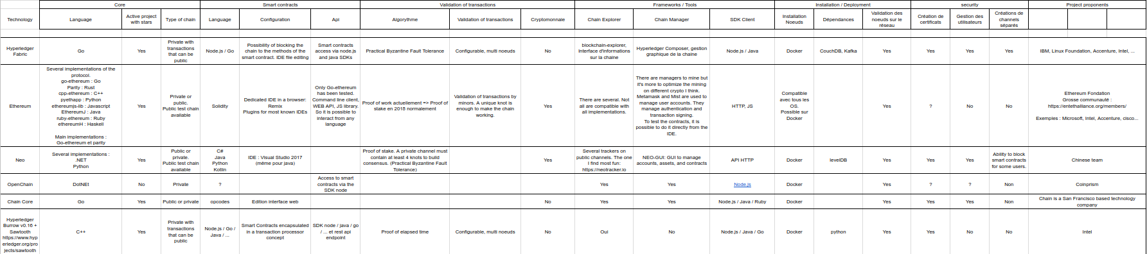

When we did our tests, it quickly became apparent that not all projects are at the same point of maturity. That’s why this table does not have many entries. The chain we selected for our use case is HyperLedger. This private system is very well documented, and has the advantage of not requiring the management of a cryptocurrency. However, it requires deploying nodes.  
Each case is different, for you to find the best solution for your project. The blockchain concept is fascinating, and this may be the next revolution in the web, so do not miss the turning point!

**Analyzing Smart Contract vulnerability:**

# Beginner’s Guide to Smart Contracts Security (1) — Using online tools to do security audit

### Overview & Incentive

This tutorial will walk you through the common smart contract vulnerabilities, how to analyze it , and how to fix it using a simple graphical interface. This is written for the general public so **no prerequisite is required**! :)

The reason I started this series is that I want to reduce the barrier for developers/non-developers to get familiar with this topic and thus reduce unnecessary security loss or being hacked easily in the future.

### Start Analyzing!

All you need to get started is a Chrome browser:)

1. **First, navigate to this website:**[**https://oyente.melon.fund**](https://oyente.melon.fund/)

This is an online smart contract compiler + a security analysis tool called **[Oyente](https://github.com/melonproject/oyente" \t "_blank)** which gives you real time information of the contract status and points out what vulnerabilities you have and where is it. I chose this tool as it can be used within the browser and has nice community and credibility.(20 contributor and 413 stars on Github)

Below is a screenshot on how the website looks like. Simply paste your smart contract code in the middle section and click **“Analyze”**.

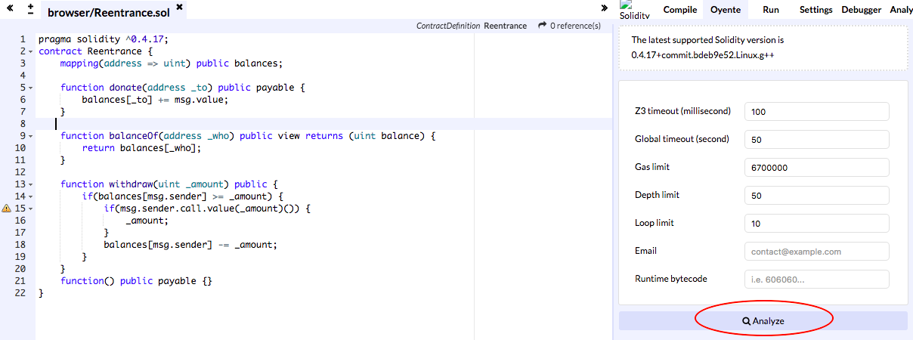

**2. Copy & paste the following code to the browser and click “Analyze”**

Here I use the vulnerability “**Reentrancy Attack**” as an example(to be explained below). The well-know [DAO attack](https://www.coindesk.com/understanding-dao-hack-journalists/) also suffered from this. Below is the smart contract example from [Ethernaut](https://ethernaut.zeppelin.solutions/level/0xf70706db003e94cfe4b5e27ffd891d5c81b39488" \t "_blank).

pragma solidity ^0.4.17;

contract Reentrance {   
 mapping(address => uint) public balances;   
   
 function donate(address \_to) public payable {   
 balances[\_to] += msg.value;   
 }   
   
 function balanceOf(address \_who) public view returns (uint balance) {   
 return balances[\_who];   
 }   
   
 function withdraw(uint \_amount) public {   
 if(balances[msg.sender] >= \_amount) {   
 if(msg.sender.call.value(\_amount)()) {  
 \_amount;   
 }   
 balances[msg.sender] -= \_amount;   
 }   
 }

function() public payable {}   
}

**3. You’ll see the analysis result in just a few seconds!**

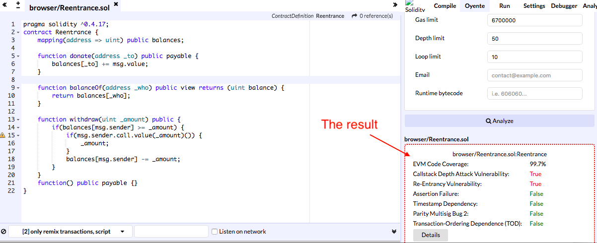

**4. Click “Details” to know exactly at which line is the vulnerability**

In the yellow box, we can tell that there are two problems in total and it is at line 15. However, noted that this is just a quick check without 100% guarantee the contract will not have other vulnerabilities.

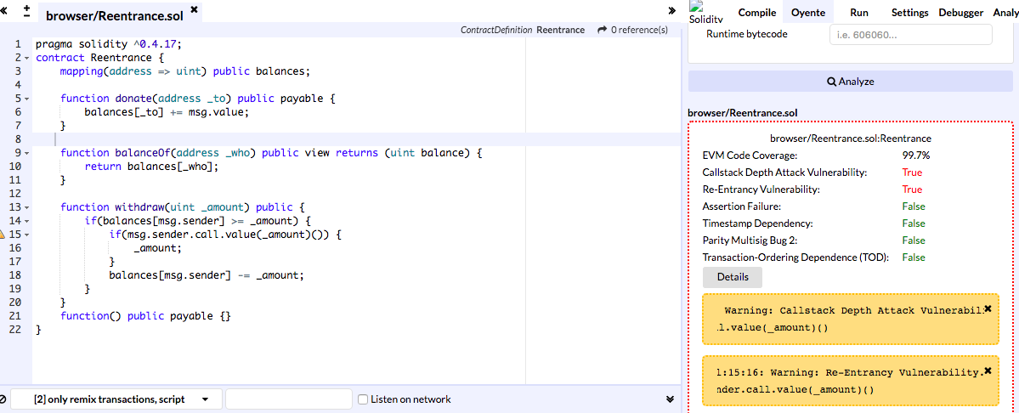

**5. Vulnerability Explanation**

Here we focus on the re-entrancy vulnerability. There are two issues here that result in this vulnerability. First, in the **withdraw()**function, balances are cleared to zero **AFTER** sending the money out to the executor of this function. This means that balances may not be zeroed properly afterwards. (What if line 15 is being executed indefinitely?)

Second, the call function at line 15 may trigger**the fallback function** if the executor is also a smart contract **given enough gas**. That is, the attacker can run the withdraw() function within its fallback function and thus result in an infinite loop draining the original contract’s balances.

**6. Quick Fix the vulnerability**

Since the fallback function’s code cannot be properly executed if the gas provided is insufficient, one possible fix is to change line 15 to the following to limit the gas to 1000. With this gas amount, only events logging will be able to execute.

if(msg.sender.call.value(\_amount).gas(1000)()) {

**7. Click “Analyze” again and see that we’ve solved the problem!**

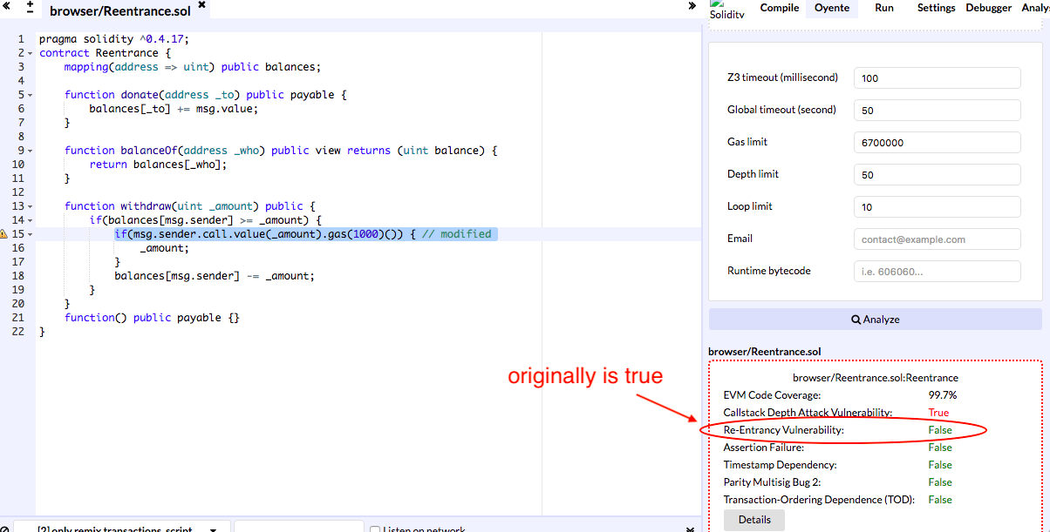

### Wrap-up

Now you know how to analyze smart contracts, what is Reentrancy Attack, and how to avoid it.

I may also write a tutorial on how a hacker can perform this attack or introduce other vulnerabilities. Feel free to comment below if you have any suggestions on future topics!!